REPUBLIC OF IRAQ

Ministry of Construction, Housing, Municipalities
And Public Works
General Authority for Buildings
&
Ministry of Health

Emergency Operation Development Projects (EODP)

Environmental and Social management Checklist
For

Rehabilitation of Sharween Clinic
in Diyala Governorate

October 24, 2019
Revision History
Version | Revision Date | Description or Reason for Change | Discipline Review | Director Review | Approval
01 | 24/10/2019 | Initial release

Prepared by: Akram Ahmad Hassan/General Authority for Buildings
Contributor: Linda Khalil (Consultant)

PART A: General Project and Site Information
INSTITUTIONAL & ADMINISTRATIVE
Country | IRAQ
Project Title | Rehabilitation of Sharween Clinic in Diyala Governorate  MOCHPM/G1/TUI/4
Institutional  arrangements | Project Owner: Building Directorate  Person in Charge:  Name: Mr. Mohamad Jaber  Title: General Director  Contact: NA  Email: NA
Local Counterpart(s): Building Directorate in Diyala
Person in Charge:
Name: Mohamad Kassem
Title: Director
Contact: 7707322469
Local Counterpart(s): Building Directorate in Diyala
Project Engineer (Supervision):
Name: Mohamad Kassem
Title: Director
Contact: 7707322469
Environmental and Social Management  Implementation  arrangements | Resident Engineer  Name: Mokhtar Osman  Contact: NA
PMT Supervision:
Name: TBD Later
Title: Environmental and Social Safeguards Officer
Contact: NA
Local Site Supervision:
Name: TBD Later
Title: NA
Directorate:
Contact: NA
Local Counterpart Supervision: NA
Contractor:
Name: TBD Later
Safeguard Supervision
Name: TBD Later
Title: NA
Contact: NA
PROJECT LOCATION & SITE DESCRIPTION
Project Location | Sharween Clinic is located in an agricultural area in Sharween, Caza of Hankeen in Diala Governorate at coordinates 34°03.082’N 44°53.276’E. It is surrounded by mainly by agricultural lands. Residential houses are at a minimum distance of 220m from the Clinic.  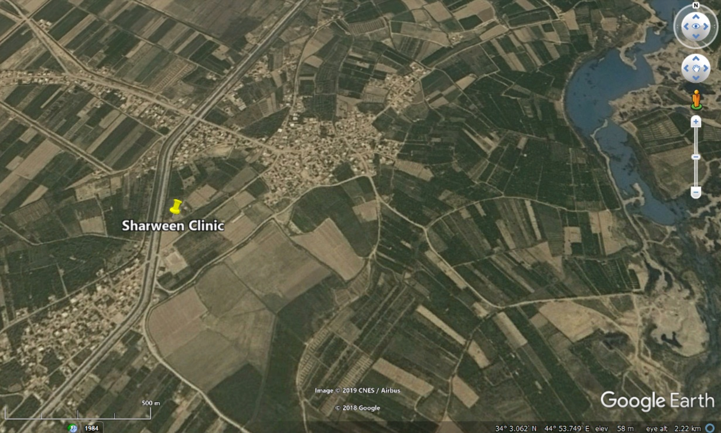  Figure 1: Google map image of the project general location
Project Description and current condition | The total population of Sharween is currently estimated at 12,831 persons. The health care service is offered by a very limited number of clinics with very limited capacities offering the basic health services only.  Sharween Clinic is currently operating although it needs rehabilitation. It is located in a single story building on a land owned by the Ministry of Health. The following figures provide a view on the current situation of the clinic. The numbers of patients that health center treated on average basis is 350 per month. The main equipment and services introduced by the health center are:  - Radiography Room (X-Ray unit) with Radiographic Units, Mobile (DR) with printer and Portable Ultrasound Machine  - OPC General Clinic Room  - Gynecology Clinic equipped with Portable ECG, Mobile Adjustable Examination Lamp, Fetal Pulse detector, Gynecological Couch and X-RAY viewer  - laboratory equipped with Single test strip chemistry analyzer, Laboratory Light Microscope, Hematology analyzer and Centrifuge  - Dental Clinic, equipped with Digital Dental Radiographic Systems and Treatment Cart  - Pharmacy Unit  - Nursing room  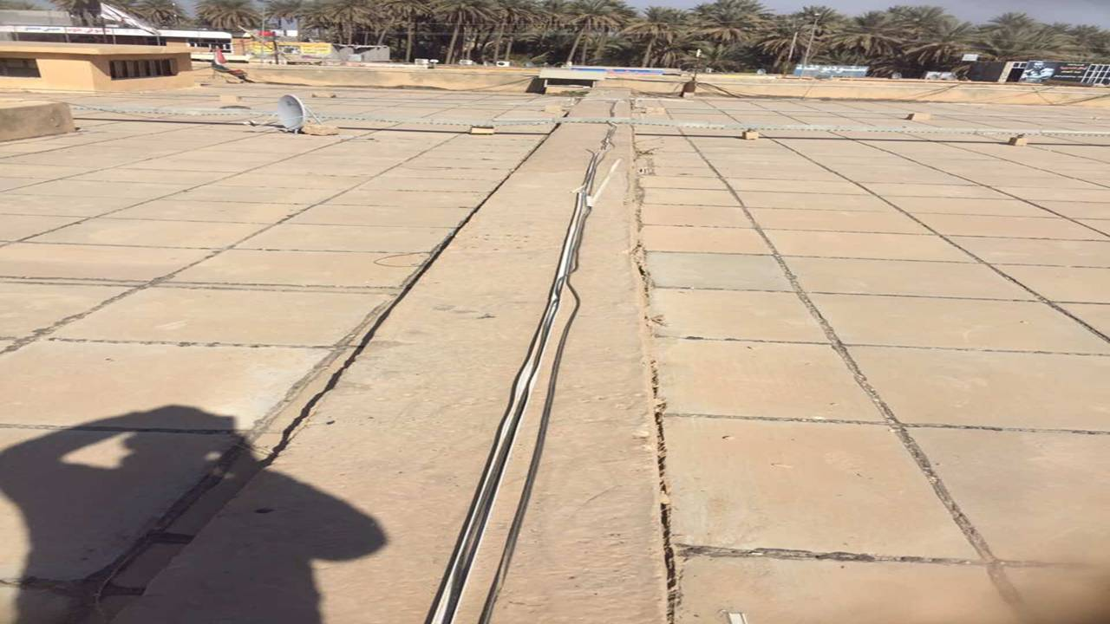  Figure 2: Current roof condition at Sharween Clinic  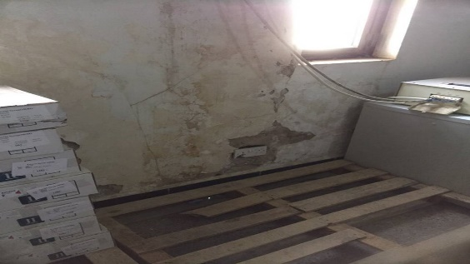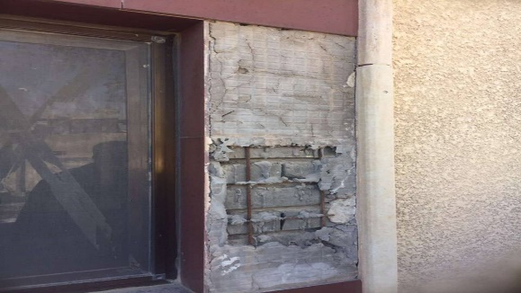  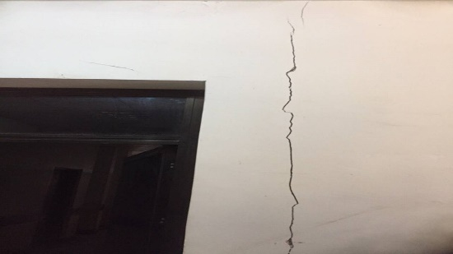  Figure 3: Photos showing the need for rehabilitation of Sharween Clinic
Project Duration | According to contract agreement, the expected project duration is 150 days.
Proposed Project Activities | The rehabilitation of Sharween Clinic consists of the following activities:  - Rehabilitation of the external walls including repair of cracks and painting  - Casting concrete floors and tiling around the building  - Installation of main panel  - Cleaning concrete roof, repairing the joints and water proofing  - Supply and Installation of doors (Wood, Aluminum and Steel)  - Painting  - Provision, linking and checking the electrical cables  - Removal of old lighting and installation of a new lighting system  - Installation of glasses  - Rehabilitation of split system  - Provision, installation, inspection and operation of wall fans  During rehabilitation, the clinic offered services will not be interrupted and there will be no need for an alternative site for a temporary clinic. The rehabilitation works are minor and the Clinic can still offer its services to the patients as required.
Land Acquisition | No temporary or permanent land acquisition is required at any stage of the project. All of the project activities will be on a land owned by the Ministry of Health. No voluntary or involuntary resettlement is required at any stage of the project.
Contactor’s Site Office | The contractor will establish a site office within the land owned by the Ministry of Health. The site office will mainly include offices, storage of material and equipment. Accommodation in the site office will not be needed as most of the workers will be from local communities and will return to their homes, consequently, no influx of external workers is expected to the project area and there will be no need to accommodate workers within the local community. The Project will require between 35-45 workers (skilled and unskilled) daily.
PROJECT BASELINE CONDITIONS
Climate | Diyala governorate is located in the northern mid-Eastern part of Iraq. The climate in the project area is desert.  The major rain falls from February thru may, with spread showering in March. Around 203 mm of precipitation fall annually. The driest months are June thru September when no rainfall (precipitation) occur, while, the wettest month is March.  The highest temperatures in Diyala reach over 41°C in July and August and lowest temperatures are around 12°C. The average annual temperature is 22.7°C.  The yearly average wind speed is 2 m/s with a maximum in January (2.7 m/s) and a minimum in November (1.3 m/s)
Air Quality | Due unavailability of air quality measuring devices, it was not possible to conduct measurements of air quality as baseline data. However, and according to the previous scattered recorded data from the Ministry of the Environment and the lack of pollutant source in the vicinity of the Project area, the air quality parameters can be considered within the acceptable levels
Noise | Similarly, noise levels near the project site are considered below the maximum allowable limits due to absence of any significant noise sources.
Flora and Fauna | The project site is located in a populated area. There is no significant observed wild life nor significant natural flora species observed in the Project area. This is mainly due to human activities and presence in the area. No rare or endangered species were identified within or nearby the project site. No protected areas are located within, or close to, the project site.
Topography | The Clinic is located in a relatively flat area.
Land use | The Clinic is surrounded by agricultural lands. Residential units are at a minimum distance of 220m from the clinic as shown in the Figure below.  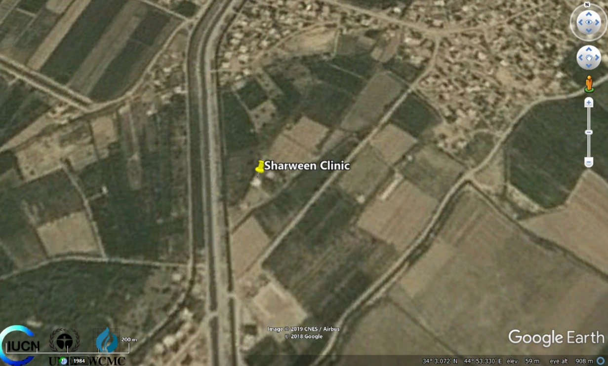  Figure 4: Land use around Sharween Clinic
Utilities and Solid Waste disposal | All the infrastructure around the Clinic is available and the clinic is connected to -domestic water supply network, electricity and wastewater network.  Regulated dumping site is located at about 5 Km from health center location. It will be used for disposal of demolition/construction wastes. Medical waste will be transported to the incinerator of Khalis hospital as mentioned in details in mitigation measures and as per the Medical Waste Management Plan (See Annex 5). The disposal will be in coordinate with Diyala Municipality directorate and with the environmental directorate.  Regulated dumping site  Figure 5: Distance from Sharween Clinic to nearest regulated dumping site
Heritage | There are no sites of cultural value in the proximity of Sharween Clinic.
Socio-economy | Sharween population is around 12,831 persons. The population is poor to very poor. Many schools went out of service because of the war, and the education system deteriorated because of the lack of resources, migration and internal displacement of teachers and students and security threats.  There are no roadside vendors near the clinic, either licensed or non-licensed who would need to be displaced because of the rehabilitation activities.  It is expected that during the rehabilitation phase, the Project will generate new temporary job opportunities for local community residents. These will be for both skilled and unskilled workers. It is agreed that, for both work categories, first preference will be given to local residents. However, in case of negative aspects that may have not been identified at this stage, the local community will be able to communicate their complaints through a Grievance Redress Mechanism (GRM) which was developed by the PMT and will be easily accessible.
Clearance of UXO/ERW | The area has received clearance from Ministry of Health/ Diyala Health Directorate for the absence of Unexploded Ordnance (UXO) / Explosive remnants of war (ERW) as attached in Annex 4. However, accidental discovery is still possible. In case of discovery, the personnel should be immediately evacuated and armed forces contacted. The works could be resumed only after removal of the munitions.
Source and Distance of Material | The required construction materials are: Aggregates, gravel, diesel fuel (for construction equipment) and water. They are available at a short distance from commercially operating sources. The construction material will be transported by trucks. The fresh water will be provided from the same area. Drinking water will be provided to workers and engineers via bottled water, which will be provided by a local supplier.
LEGISLATION& POLICIES
Legislation and Policies | The Iraqi applicable laws (Law no. 37 of 2008, Instructions issued by the Ministry of Health pursuant of Law no. 25 of 1967, Law no. 27 of 2009, Laws No.3 issued in 1997, Regulations no. 2 of 2001), instruction no.1 of 2015 (management of medical waste) and other relevant World Bank Operational Procedures will be followed (OP/BP 4.01 - Environmental assessment procedure).  OP 4.12 does not apply in this specific project because rehabilitation will be confined to existing clinic and no involuntary resettlement is expected. (See Annex 1 for details).  Health and Safety Occupational Procedure Plan shall also apply (See Annex 2 for details).
PUBLIC CONSULTATION
Public Consultation Process | Individual interviews with the local people were conducted. The face to-face interviews took place with 11 males and 9 females of local individuals in the surrounding community randomly on June 17, 2019 and on August 27, 2019. Additional public consultation was done on September 3, 2019 to reflect a wide range of locals’ opinion. (See Annex 3 for details)  A set of questions was prepared to cover the key environmental and social aspects related to the project (See Annex 3 for details). Local residents were consulted using face-to-face interviews with randomly selected individuals near the Clinic and in different areas of the community to have their opinions and thoughts.  The purpose of the consultation was to obtain sound and representative information on the possible socio-economic circumstances of the local community members, and better understand any possible adverse socio-economic effects of project activities on the Project Affected Persons (PAPs) and the local community resulting from the project under study.  The results revealed from these questioners and the consultation can be summarized as follows:  - The local community agreed that, the repair of the Clinic will have a highly positive impact on their social daily life (See Annex 3 for details).  - None of the locals expressed any reservation against the project nor specified any negative impact that might affect him or his family. People are eager to rebuild and get back to practice their ordinary safe life such project won't just help them to achieve that, but it will help them to restore their faith back in the government.  - No environmental or social concerns were raised during the consultations.  - All consulted persons expressed the need to complete the clinic rehabilitation as soon as possible as it will help improve their livelihood conditions.No environmental or social concerns were raised by the interviewed.  - Nine (9) interviewed persons asked for the installation of warning and directional signage during the rehabilitation activities. (See Annex 3 for details).  - Consulted person asked if the services will be interrupted during consultations and the representatives of the MoH confirmed that the services offered by the clinic will not be affected.  - Questions were raised about the project duration and types of works involved and were duly answered by the representatives of Ministry of Construction, Housing, Municipalities and Public Works  The mechanism of Grievance Redress was also explained to all the interviewed.

GRIEVANCE REDRESS MECHANISM
Grievance Redress Mechanism | Bank procedures require that GRMs be established and operational prior to commencement of the construction works related to the project, and that they continue to operate for one year following completion of the works.  Accordingly, a GRM was established at the project level to ensure any grievance can be addressed. The GRM system for the Project under study was designed in a way that is inclusive and responsive. This GRM takes into account the availability of judicial recourse as well as traditional and community dispute resolution mechanisms.  Resolving complaints at community level is always encouraged to address the problem that a person or a group may have during implementation and/or operational phase. The GRM allows for anonymous uptake locations in case the complainant does not want to reveal his identity. The GRM allows a safe space for complainants of various groups including the most vulnerable groups, to file complaints and ensure that the process is free of retaliation. The project grievance redressed system was developed in consultation with communities, it includes the following steps for written complaints:  - First, the affected person sends his/her grievance in writing to the PMT. The grievance note should be signed and dated by the aggrieved person. Where the affected person is unable to write, s/he should obtain assistance from the PMT to write the note and mark the letter with his/her thumbprint. The PMT should respond within 14 days. For this purpose, complaints boxes will also be placed in each department of the resident engineer in case the complainant prefers to remain anonymous. The coordinator of the Social Unit will be responsible for handling the complaints and provide an answer to the complainant within 48 hours.  - Second, if the aggrieved person is not satisfied with the solution of PMT, s/he can go to the court.  The PMT must maintain records of grievances and complaints, including minutes of discussions, recommendations and resolutions made.  A hotline (0770033946921) and an email address (pmt.mabany@gmail.com) were also put in service for the purpose of complaints. The hotline number and details will be posted at the subproject signboard in Arabic. Additionally, the details of the GRM will be distributed among locals and awareness raising campaigns about the process of GRM will take place regularly.
INSTITUTIONAL CAPACITY BUILDING
Will there be any capacity building? | [X] N or [] Y

PART B: safeguards SCREENING AND Triggers
ENVIRONMENTAL /SOCIAL SCREENING FOR SAFEGUARDS TRIGGERS
Will the site activity include/involve any of the following? | Activity/ Typology | Status | Triggered Actions
 | - Maintenance(or/and) reconstruction of urban(or/and) rural roads | [ ] Yes [x] No
 | - Reconstruction of private homes, housing estates or public buildings | [x] Yes [ ]No | See Part C Section A below
 | - Reconstruction of / impacts on surface drainage system | [ ] Yes [ x] No
 | - Activities in Historic building(s) and districts | [ ] Yes [x ]No
 | - Required acquisition of land or temporary / permanent impacts on livelihoods | [ ] Yes [x]No
 | - Handling or presence of hazardous or toxic materials | [x] Yes [ ] No | See Part C Section B below
 | - Impacts on forests and/or protected areas | [ ] Yes [x]No
 | - Risk of unexploded ordinance (UXO) | [x] Yes [] No | See Part C Section C below
 | - Traffic and Pedestrian Safety | [ ] Yes [x] No

PART C: Mitigation measures
ACTIVITY | PARAMETER | MITIGATION MEASURES CHECKLIST
General Conditions | Notification and Workers Safety  (See Annex 2 for detailed measures on Health and Safety) | - The local construction and environment inspectorates and communities have been notified of upcoming activities.  - The public has been notified of the works through appropriate notification in the media and/or at publicly accessible sites (including the site of the works).  - All legally required permits have been acquired for the maintenance activities.  - The Contractor formally agrees that all work will be carried out in a safe and disciplined manner designed to minimize impacts on neighboring residents and environment.  - The Contractor formally agrees and make sure all types of workers are covered with insurance.  - Workers’ Personal Protective Equipment (PPE) will comply with international good practices (always hardhats, as needed masks and safety glasses, harnesses and safety boots).  - Appropriate signs and instructional banners within the sites will inform workers of key rules and regulations to follow.  - The Project owner shall ensure an effective GRM is in place to deal with any potential complaints/concerns.  - A child under the age of 18 should not be employed or engaged in connection with the project in a manner that is likely to be hazardous or interfere with the child’s education or be harmful to the child health or physical, mental and social development.
Section A: General Rehabilitation and /or Construction Activities | Air Quality | - During works dust control measures shall be employed, e.g. by spraying and moistening the ground  - Demolition debris excavated soil and aggregates shall be kept in controlled area and sprayed with water mist to reduce debris dust  - During pneumatic drilling or breaking of concrete dust shall be suppressed by ongoing water spraying.  - The surrounding environment shall be kept free of soil and debris to minimize dust.  - There will be no open burning of construction / waste material at the site.  - All machinery will comply with Iraq emission regulations, they shall be well maintained and serviced and there will be no excessive idling of construction vehicles at sites
 | Noise | - Construction noise will be limited to restricted times agreed to in the permit (8 am to 3 pm)  - During operations of the engines, covers of generators, air compressors and other powered mechanical equipment shall be closed, and equipment placed as far away from residential areas as possible. The operational period for the probable noisy equipment will be minimized.
 | Water Quality | - Sewage from construction offices will be connected to the wastewater network.
 | Waste Management | - The on-site waste generation shall be minimized and segregated.  - Waste collection and disposal pathways and sites will be identified for all major waste types expected rehabilitation activities.  - Construction and demolition wastes will be separated from general refuse, organic, liquid and chemical wastes by on-site sorting and stored in appropriate containers.  - Construction waste will be collected and disposed properly by licensed collectors as agreed with Ministry and local authorities.  - The records of wastes disposals will be maintained as proof for proper management as designed.  - Simple waste management plan for specific waste streams must be developed.  - General waste must be collected and transported to approved disposal sites.  - Waste containers must be located at each worksite.  - Storage, transport and handling of all chemicals wastes must be conducted in accordance with all legislative requirements, through licensed contractors and in coordination with the local authority.  - The contractor agreed to transport the demolition/ construction waste generated to a landfill of Sharween belonging to Sharween Municipality 5 km far away from the health center location.
 | Community health and safety | - Prepare and implement a mandatory code of conduct for all the laborers to make sure inhabitants are not impacted by the presence of laborers or by any negative behavior or misconduct from the workers.  - Avoid or minimize the potential for community exposure to hazardous materials and substances that may be released by the Project.  - Apply the concept of universal access to the design and construction of buildings or any structures where technically and financially feasible (i.e. access to all users, including persons with disabilities such as wheelchair users)  - d) The law imposes an affirmative obligation on employers to maintain a workplace free from all forms of discrimination including sexual harassment. The employer’s obligation includes a requirement to train supervisors on sexual harassment prevention. The training and awareness raising for workers should be continue through daily toolbox talks and other training opportunities.
Section B: Toxic materials | Toxic / hazardous waste management/medical waste | - Temporarily storage on site of all hazardous or toxic substances will be in safe containers labeled with details of composition, properties and handling information  - The containers of hazardous substances shall be placed in a leak-proof container to prevent spillage.  - The wastes shall be transported by specially licensed carriers and disposed in a licensed facility.  - Medical waste will be managed according to medical waste management that classifies waste, estimate quantities, estimate the storage, transporter and disposal. This plan follows the instruction NO. (1) for the year 2015. Medical waste will be transported to the incinerator of Khalis hospital located in the same area to deal with. A copy of Jalawla medical waste management plan is attached in Annex 5.  - Paints with toxic ingredients or solvents or lead-based paints will not be used  - All hazardous wastes must be appropriately stored in bounded areas and should be clearly identified as “hazardous”.  - Transportation and disposal of hazardous wastes should be done through licensed contractors and in close coordination with the relevant local authority and in compliance with the legal requirements and instructions of the coordination with Ministry of Health.  - Hazardous liquids, such as solvents, rust proofing agents and primer must be managed in accordance with the requirements of relevant legislation and industry standards.  - A hazardous materials inventory for the construction period must be prepared.  - Material Safety Data Sheets (MSDS) for hazardous materials must be available on-site during construction and made available and explained to workers.  - Hydrocarbon wastes, including lube oils, must be collected for safe transport off-site for reuse, recycling, transport or disposal at approved locations nominated by the Municipality and the Ministry of Health and Environment.
Section C: Risk of unexploded ordinance (UXO) | Unexploded ordinance (UXO) | - clearance from the military or other responsible agency

PART D: Monitoring Plan
Table (1) Summary of ESMP during Rehabilitation Phase
No. | Potential Impacts | Mitigation Measures | Monitoring | Responsibility |  | Additional Cost in USD
 |  |  |  | Implementation | Monitoring | Mitigation measures | Monitoring
1 | Generation, storage, disposal of construction and domestic waste | - Waste minimization concept must be adopted and applied;  - Storage of construction waste in locations nominated by the municipality and the Ministry of the Environment;  - Waste disposal in designated locations;  - Coarse and fine waste materials should be used as filling, construction (as possible) and stabilization material;  - Handling of liquid waste in sealed containers as possible;  - Simple waste management plan for specific waste streams must be developed;  - General waste must be collected and transported to the local municipality approved disposal sites;  - Waste containers must be located at each worksite;  - Storage, transport and handling of all chemicals must be conducted in accordance with all legislative requirements, through licensed contractors and in coordination with the local authority;  - All hazardous wastes must be appropriately stored in bounded areas and should be clearly identified as “hazardous”;  - Transportation and disposal of hazardous wastes should be done through licensed contractors and in close coordination with the relevant local authority and in compliance with the legal requirements and instructions of the coordination with the ministry of science and technology;  - Hazardous liquids, such as solvents, rust proofing agents and primer must be managed in accordance with the requirements of relevant legislation and industry standards;  - A hazardous materials inventory for the construction period must be prepared.  - Material Safety Data Sheets (MSDS) for hazardous materials must be available on-site during construction and made available and explained to workers;  - Hydrocarbon wastes, including lube oils, must be collected for safe transport off-site for reuse, recycling, transport or disposal at approved locations;  - Accidents due to the hazardous waste dispersion response and cleanup plan must be presented by the contractor and approved latterly as mitigated for impacts. | - A monitoring routine must be conducted.  - Continual instructions and awareness procedures must be implemented.  - Maintaining a record of type, quantity and disposal location of solid and liquid waste generation  - Frequency: Twice a month | Contractor | Resident Engineer | Included within the contract bidding | Included within the contract bidding documents
2 | Deterioration of air quality | - Usage of well-maintained equipment;  - Engines of vehicles and other machinery are kept turned on only if necessary, avoiding any unnecessary emission;  - Machines and equipment are periodically checked and maintained to ensure their good working condition;  - All equipment and machines must be maintained and tested for compliance with standards and technical regulations for the protection of the environment and have appropriate certifications;  - Activities are carried out using the minimum required number of means at the same time;  - Electric small-scale mechanization and technical tools are used when available and feasible;  - Concerning dust control methods and measures, the following actions are to be taken into account to reduce the generation of dust:  - Watering or increase of the moisture level of the open materials storage piles to reduce dust levels;  - Enclosure or covering of inactive piles to reduce wind erosion;  - Loads in all trucks transporting dust-generating materials have to be sprayed with water to suppress dust, as well as wheels of means moving inside and outside of the construction-site;  - Using good quality fuel to reduce exhaust emissions;  - Water spraying for dust control;  - Cleaning of vehicle tires;  - Covering of trucks carrying fine grade construction materials;  - Avoiding earthworks near settlements and dust generation. | - Visual observation and photographic documentation of equipment induced emissions and dust clouds from works and trucks  - Frequency: twice a month | Contractors | Resident Engineer | Included within the contract bidding documents | Included within the contract bidding documents
3 | Increased level of Noise | - Activities are to take place within reasonable hours during the day and early evening. Night-time activities near noise sensitive areas, such as residential buildings, should not be allowed;  - Equipment must be kept in good working order and where appropriate fitted with silencers which are kept in good working order;  - Equipment to run only when necessary;  - Positioning of the noise sources in a concealed area with respect to acoustic receptors, consistent with the needs of the construction site;  - Usage of quiet/well-maintained equipment;  - Limiting noisy activities to normal daylight hours;  - Informing local population about noisy works; | - Site supervision, inspection and documentation to ensure the implementation  - Frequency: Once /week | Contractor | Resident Engineer | Included within the contract bidding documents | Included within the contract bidding documents
8 | Deterioration of health & safety conditions | - Qualified personnel must be employed for the construction equipment, and personnel must be trained for health and safety issues;  - Personal protection equipment such as eyeglasses, gloves, hard heads and safety belts must be supplied and continuously used all workers, technicians, engineers and site visitors;  - Adherence to local and international guidance and codes of practice on Environmental Health and Safety (EHS) management during construction;  - Implement the related EHS Procedures, including a Construction OHS Plan  - Clear definition of the EHS roles and responsibilities of the companies involved in construction and to individual staff (including the nomination of EHS supervisors during construction);  - Provision of appropriate training on EHS issues for all construction and operation workers, including initial induction and regular refresher training, taking into account local cultural issues;  - Regular inspection, review and recording of EHS performance;  - Maintenance of a high standard of housekeeping at all times;  - Provision of all types of workers’ insurance. A registration/attendance system on site needs to be introduced and filled daily for the workers on site;  - Assurance that child labor is strictly prohibited. | - Inspection and photo evidence  - Maintaining records of injuries and accidents with cause and location  - Maintaining daily records of registration/attendance system on site  - Frequency: weekly | Contractor | Resident Engineer and PMT | Included within the contract bidding documents | Included within the contract bidding documents
9 | Social Impacts | - Coordinating with the public schedule of maintenance activities in residential areas  - Employ local workers  - Construction offices must be connected to wastewater network and equipped with waste containers.  - A GRM shall be established to enable the community to raise complaints  - Workers shall commit to abide by the code of conduct that shall be prepared by the contractor and approved by the PMT. | - Site inspection and documentation of community activities near the project area  - Inspections of working site  - Inspection of the GRM records  - Frequency: Bi-weekly | Contractor in coordination with Supervision Engineer | Resident Engineer | Included within the contract bidding documents | Included within the contract bidding documents
TOTAL |  |  |  |  |  | All costs are included in contract bidding documents | All costs are included in contract bidding documents

- As a part of the payment conditions 10% of each payment certificate (invoice) will be withheld for the ESMP activities and will be released for payment after the supervising engineer has confirmed that relevant activities and mitigation measures of the E&S requirements are completed in satisfactory manner.

Table (1) Summary of ESMP during Operation Phase.

No. | Potential Impacts | Mitigation Measures | Monitoring | Responsibility |  | Additional Cost in USD
 |  |  |  | Implementation | Monitoring | Mitigation measures | Monitoring
1 | Increase in Health care and municipal waste generation | - Waste minimization concept must be adopted and applied;  - Food wastes must be collected, where practicable, considering health and hygiene issues, for disposal off-site through licensed contractors;  - Implement Health Care Waste management plan. (Annex 5) | - A monitoring routine must be conducted.  - Frequency: Twice a month | Management of the Clinic | Ministry of Environment | Within the legal duties | Within the legal duties
2 | Social Impacts | - Enhance the existing GRM and put in place strong communication and outreach activities that would inform populations on the services and benefits available and their eligibility for services. | - GRM Record and record on patients served  - Frequency: Monthly | Management of the Clinic | Ministry of Health | Within the legal duties | Within the legal duties
3 | Safety of workers and infection control | - implementing Hazardous waste management plan  - Provide adequate PPEs to doctors waste collectors and authorized personnel  - Raise workers awareness | - Injuries records  - Frequency: weekly | Management of the Clinic | Ministry of Health | Within the legal duties | Within the legal duties
TOTAL

Annex 1:

1 Iraqi environmental legislation
During rehabilitation and operation, the work must follow the Iraqi laws and regulations for the environmental standards. These are:
- Laws of the environment protection No.3 issued in 1997 and the published regulations. The environmental regulations for gaseous emissions, noise and other air pollution standards are not in force and legally binding. However, limits for water disposal in any surface waters and main sewers are subject to regulation no. (25)/1967 and its modifications published by the Ministry of Health (MOH) and the Ministry of Environment (MOE).
- Law of heritage and antiques no. (55) issued in 2002. This law defines all movable and immovable antiquities, archaeological properties and artifacts in Iraq. It regulates communication channels between the public and the authorities for each type of contact between the public and the revealed and non-revealed archaeological sites.
- New environmental framework Law No. 27 of 2009 for the Iraqi national government. This Law was introduced but its executive decrees remain to be prepared. The requirements for environmental assessment are not legally binding.
- Regulations governing contact with archaeological sites extend also to encompass developmental activities like road construction and rehabilitation wherever these developmental activities lie within archaeological vicinity.
- Regulations of the MOE on sanitary waste must be followed, and for the rubbles (construction & demolition waste) the regulations, legislations and instruction of MOE and Ministry of Construction, Housing and Public Municipalities (MOCHPM).

The following Table summarizes the Iraqi’s laws applicable to the project's activity.
Applicable Iraqi Law | Subject
Law no. 37 of 2008 | Describes institutional arrangements of the MOE and outlines policies and roles and responsibilities toward protecting the environment.
Instructions issued by the Ministry of Health pursuant of Law no. 25 of 1967 | Contamination limits and protection of rivers.
Law no. 27 of 2009 | Protection and Improvement of Environment
Laws No.3 issued in 1997 | Environment protection
Regulations no. 2 of 2001 | Preserving water resources.
Instruction no. 1 of 2015 | Medical Waste Management

Legally, the works under rehabilitation and operation must follow the Iraqi laws and the regulations for the Environmental Standards. These are laws of the environment protection No.3 issued in 1997 and the published regulations. The following should be noted:
- There are no environmental regulations for gaseous emissions, noise and other air pollution standards that are and legally binding.
- Water disposal into any surface waters and main sewers is regulated by regulation by regulation no. (25)/1967 and its modifications released by the MOH and MOE
- The Law of heritage and antiques no. (55) was Issued in 2002,
- The sanitary waste (municipal) disposal should follow the regulations of the MOE
- For rubbles (construction &demolition waste) the regulations, legislations and instruction of both MOE and MOCHPM must be followed.
It should be noted that legislation related to social safeguards issued in Iraq since 2003 has focused primarily on the ratification of international conventions and protocols on issues such as cultural heritage. Currently, there aren't Law related to social and environmental assessment.

2 The World Bank Safeguards Policies
In addition to the Iraqi laws and regulations the ESIA follows the policies and procedures of the WB. The following section presents the WB operational policies that are relevant to the rehabilitation of the bridges that ensure that projects proposed for Bank financing are environmentally and socially sound and sustainable.

4.2.1 OP/BP 4.01 - Environmental assessment procedure
The Bank requires environmental assessment (EA) of projects proposed for Bank financing. The objectives of the EA are to:
- Inform decision makers of the nature of environmental and social risks.
- Increase transparency and participation of stakeholders in the decision-making process.

4.2.2 OP/BP4.12 - Involuntary resettlement
OP/BP 4.12 focuses on the following principles:
- Involuntary resettlement is avoided wherever feasible, or minimized, exploring all viable alternative project designs;
- Where it is not feasible to avoid involuntary resettlement, activities are conceived and executed as sustainable development programs. Displaced persons are to be meaningfully consulted and have opportunities to participate in the planning and implementing of resettlement programs affecting them; and
- Displaced persons are assisted in their efforts to improve their livelihoods and standards of living, or at least to restore them, in real terms, to pre-displacement levels or to levels prevailing prior to the beginning of project implementation, whichever is higher. The mechanism of assisting displaced persons is based on full and prior mitigation and compensation for loss of assets or livelihoods.
- OP 4.12 applies whenever, in a Bank-financed project, land is acquired involuntarily, or access is restricted in legally designated parks or protected areas.
- In this specific project, OP 4.12 does not apply as the works consist of reparation and rehabilitation of an existing building and no land acquisition is needed neither permanently nor temporarily.

Annex 2: Occupational Health and Safety
The objectives of occupational health and safety (OHS) procedures plan that should be applied for the project are to:
- Develop, in the workplace, a collaborative approach to managing Occupational health and Safety between management and workers.
- Provide and maintain safe working procedures and operations.
- Ensure awareness of all potential work-related risks and hazards and to develop preventive strategies against these risks and hazard.
- Provide appropriate training to all concerned to work safely and effectively.
- Maintain a constant and continuing interest in the improvement of occupational health and safety performance and to provide the required resources necessary for the implementation and maintenance of the OHS plan.

For the projects of the Rehabilitation of Civil Works Project, the occupational health and safety primarily focuses on work equipment and protective gear. The following section provides guidelines for work equipment, and safety and health signs.
Safety Guidelines for Work Equipment
It is the Contractor’s obligation that every possible measure is taken to ensure the safety of the work equipment made available to workers. During the selection of the work equipment the employer shall pay attention to the specific working conditions, which exist at the workplace, especially in relation to safety and health of workers. A brief list of work equipment safety issues is given below:
- Work equipment control devices which affect safety must be clearly visible and identifiable and appropriately marked where necessary.
- Work equipment presenting hazards due to emissions of gas, vapor, liquid or dust must be fitted with appropriate containment and/or extraction devices near the sources of the hazard.
- Where there is a risk of mechanical contact with moving parts of work equipment, which could lead to accidents, those parts must be provided with guards or devices to prevent access to danger zones or to halt movements of dangerous parts before the danger zones are reached.
- Work equipment may be used only for operations and under conditions for which it is appropriate.
- Work equipment must bear the warnings and markings essential to ensure the safety of workers.
- All work equipment must be appropriate for protecting workers against the risk of the work equipment catching fire or overheating, or of discharges of gas, dust, liquid, vapor or other substances produced, used or stored in the work equipment.
- All work equipment must be appropriate for preventing the risk of explosion of the work equipment or of substances produced, used or stored in the work equipment.
- All work equipment must be appropriate for protecting exposed workers against the risk of direct or indirect contact with electricity.
- Mobile work equipment such as Bulldozer or Road Rollers with ride-on workers must be designed to restrict, under actual conditions of use, the risks arising from work equipment roll-over.
- Fork-lift trucks carrying one or more workers must be adapted or equipped to limit the risk of the fork-lift truck overturning.
- Self-propelled work equipment, such percussion drills, which may, when in motion, engender risks for persons must have facilities for unauthorized start-up.
- Machinery for lifting loads, such as Crane, must be clearly marked to indicate its nominal load, and must where appropriate be fitted with a load plate giving the nominal load for each configuration of the machinery.
- Work equipment must be erected or dismantled under safe conditions, in particular observing any instructions, which may have been furnished by the manufacturer.
- First aid facilities must be available on site at all times.
- All equipment is maintained in a safe operating condition.
- Personal Protective Equipment (PPE) available for all construction staff. Helmets and safety shoes must be worn at all times and other PPE worn were necessary i.e. dust masks, ear plugs etc.
- Adequate warning signs of hazardous working areas.
- Emergency numbers for local police and fire department will be placed in a prominent area.
- Firefighting equipment will be placed in prominent positions across the site where it is easily accessible. This includes fire extinguishers, a fire blanket as well as a water tank.
- No open fires will be allowed on site.

Annex 3: INDIVIDUALS INTERVIEW
English Form of the Questionnaire
1 | In your opinion, would the rehabilitation of the clinic have positive impact on the residents of the area? | yes | no
2 | Are there any claims on private land ownership in the project area? | yes | no
3 | Would there be any damage to income generating crops, trees, and vegetation due to the rehabilitation activities? | yes | no
4 | Would there be any losses of income of local residents due to the rehabilitation activities? | yes | no
5 | Would there be any damages whether permanent or temporary which would affect the livelihood of the residents due to the rehabilitation activities? | yes | no
6 | Would the rehabilitation activities induce the resettlement of inhabitants due to works? | yes | no
7 | Is there any usage by local residents of the facilities or land of the facilities by the local residents? | yes | no
8 | In your opinion, would there be any negative social impacts due to the rehabilitation activities? | yes | no
9 | Would there be any changes to the demographics or social structure in the project area induced by the rehabilitation activities? | yes | no
10 | Would there be any damages to the structures or houses induced by the rehabilitation activities? | yes | no
11 | Will the project reduce the isolation of the communities adjacent to the clinic? | yes | no
12 | Is there any need for warning and directional signage during the rehabilitation activities? | yes | no
Signature:
Name of the Respondent:
Occupation of the respondent:
Date of interview:

Name of the Respondent (1) | Mohammed Ali Thabit (Male)
Occupation of the Respondent | -
Date | 17/6/2019

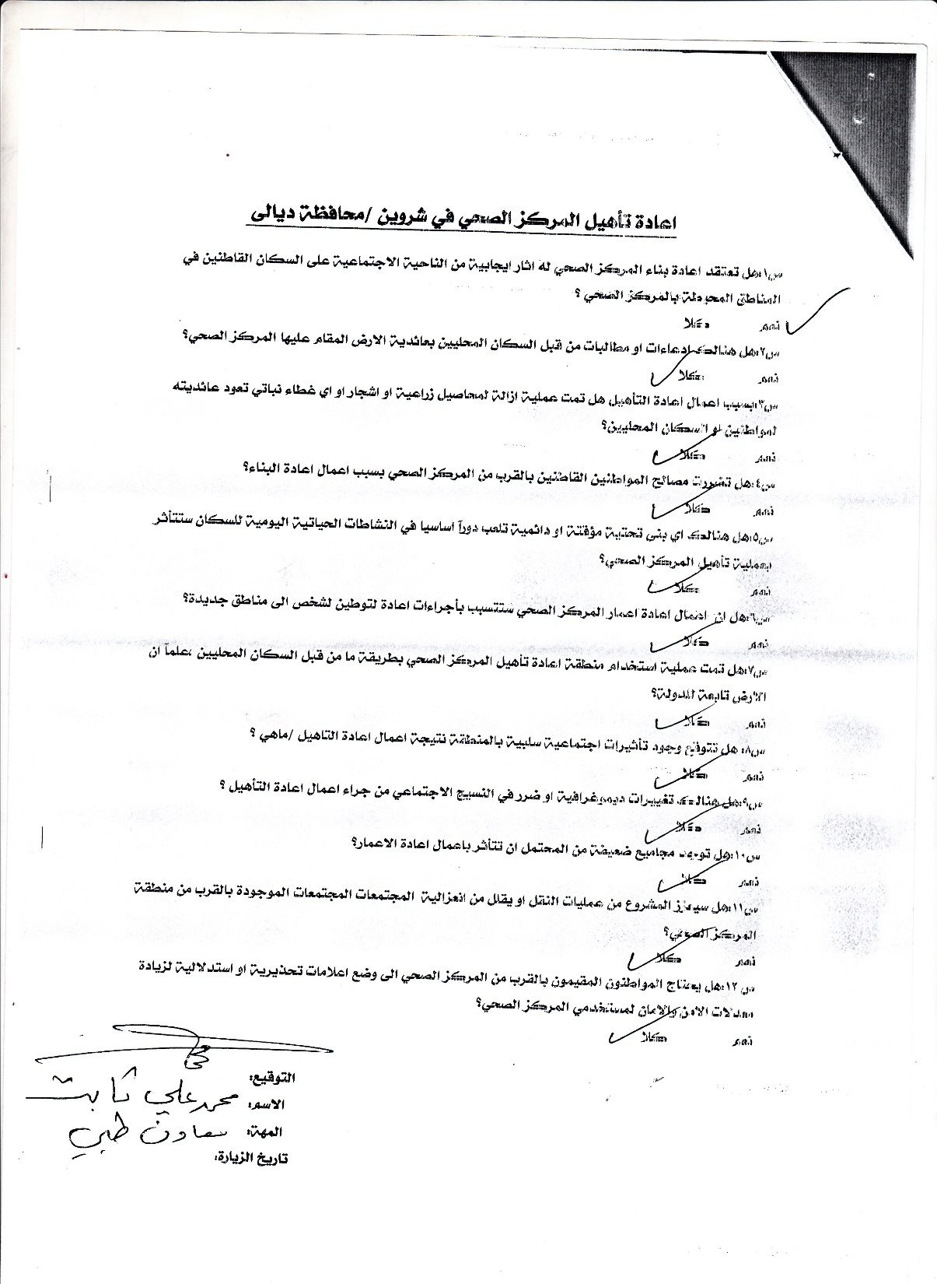
Name of the Respondent (2) | Modher Amin Ali (Male)
Occupation of the Respondent | Employee
Date | 17/6/2019

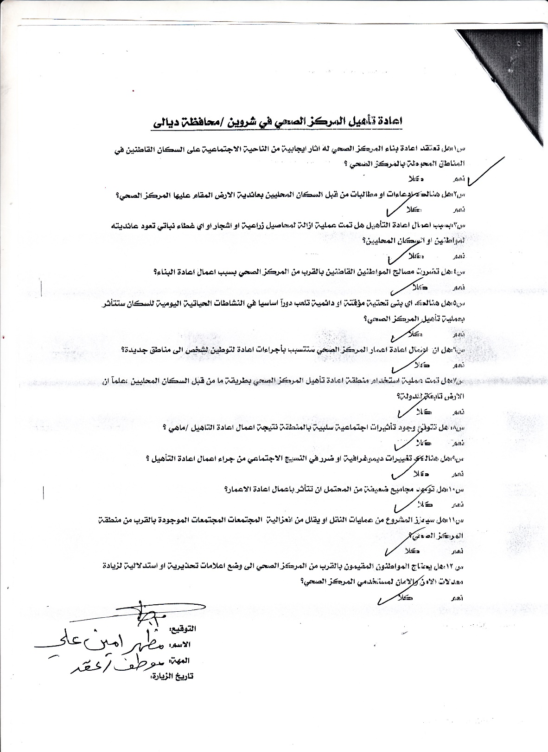
Name of the Respondent (3) | Mohammed Alwan Khalaf (Male)
Occupation of the Respondent | Retired
Date | 17/6/2019

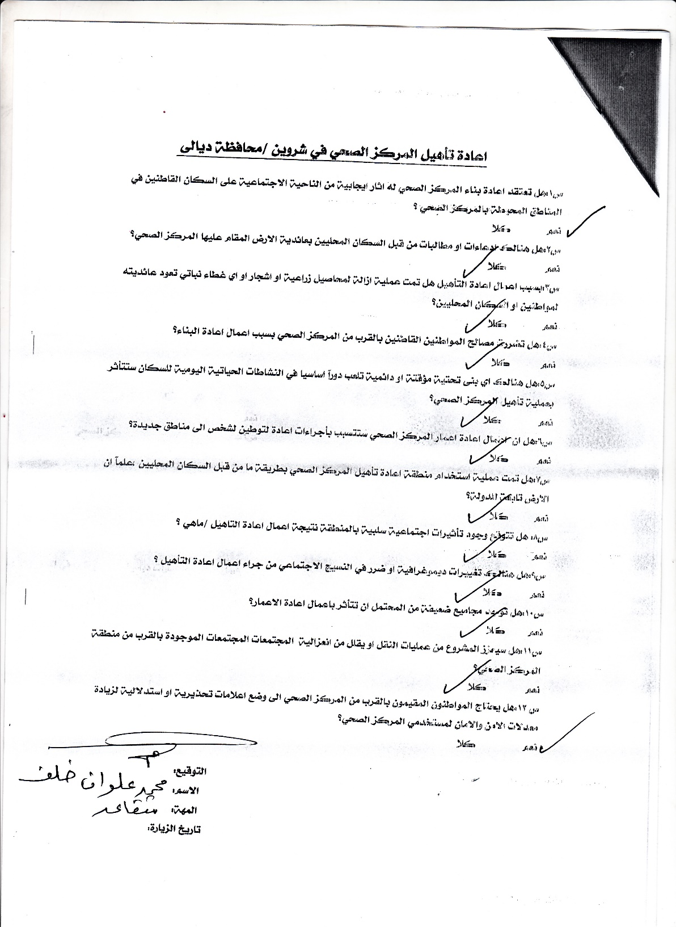
Name of the Respondent (4) | Khalid Mahmood Hussein (Male)
Occupation of the Respondent | Retired
Date | 17/6/2019

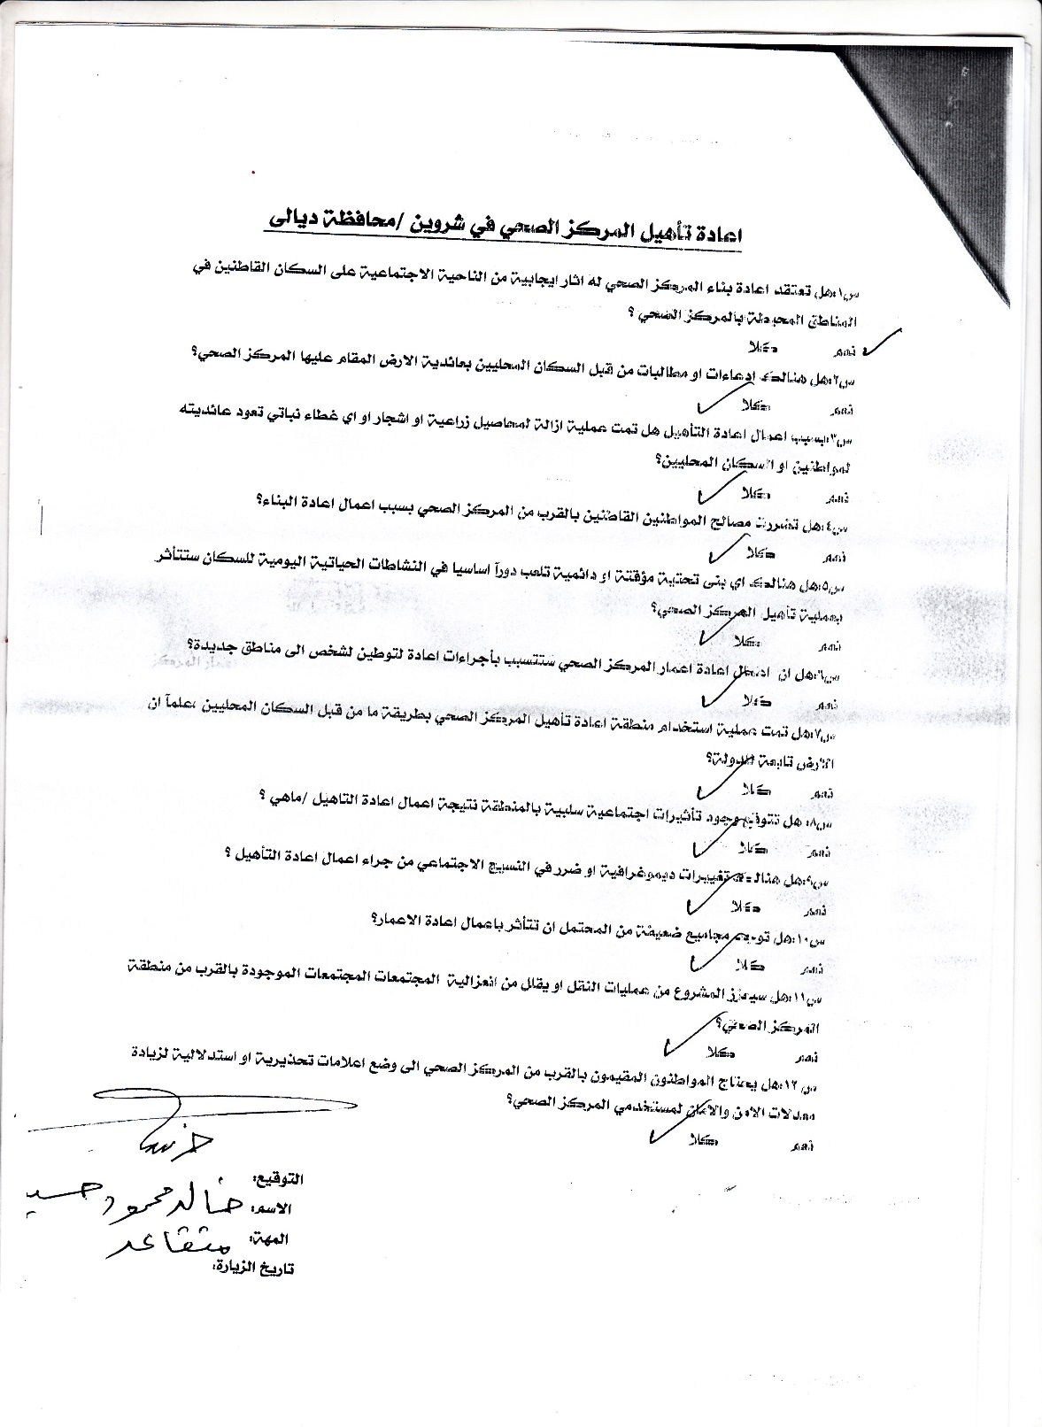
Name of the Respondent (5) | Youssef Omran Mare’e (Male)
Occupation of the Respondent | Laborer
Date | 17/6/2019

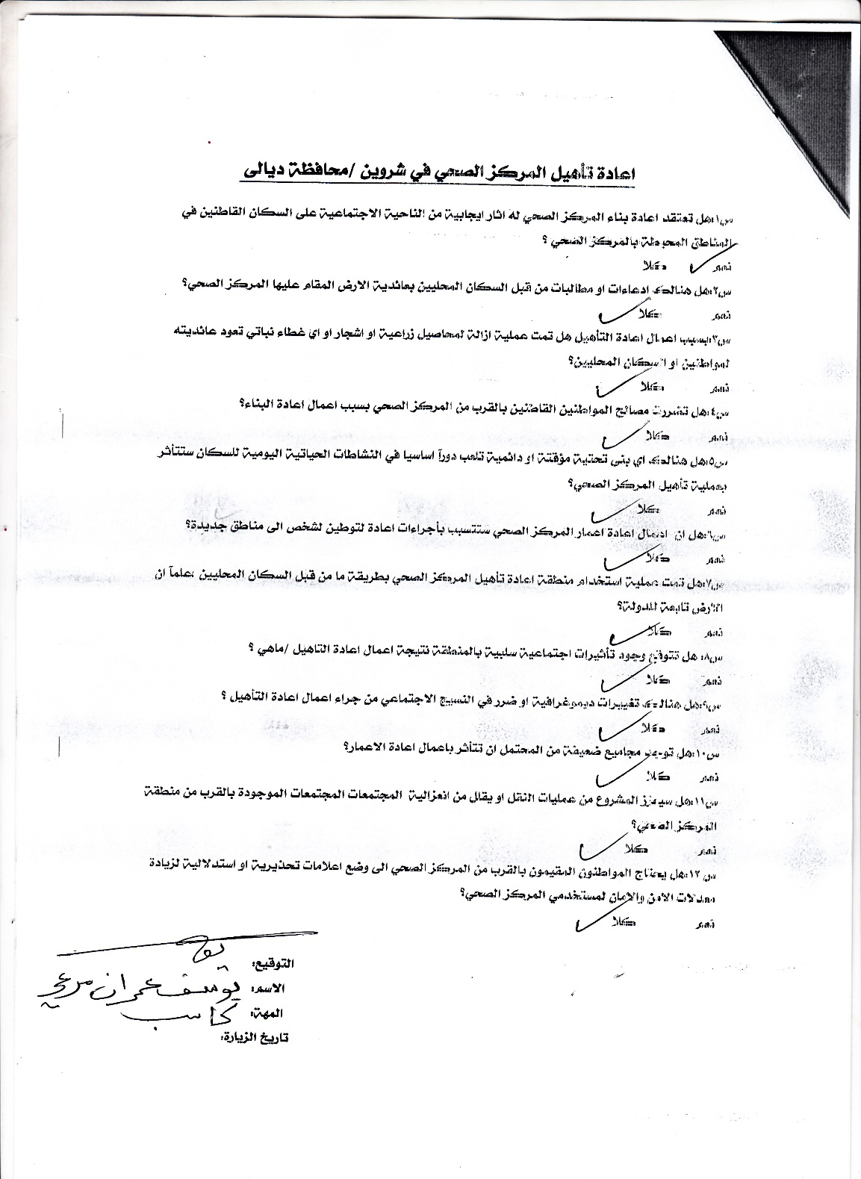
Name of the Respondent (6) | Omar Kareem Youssef (Male)
Occupation of the Respondent | -
Date | 17/6/2019

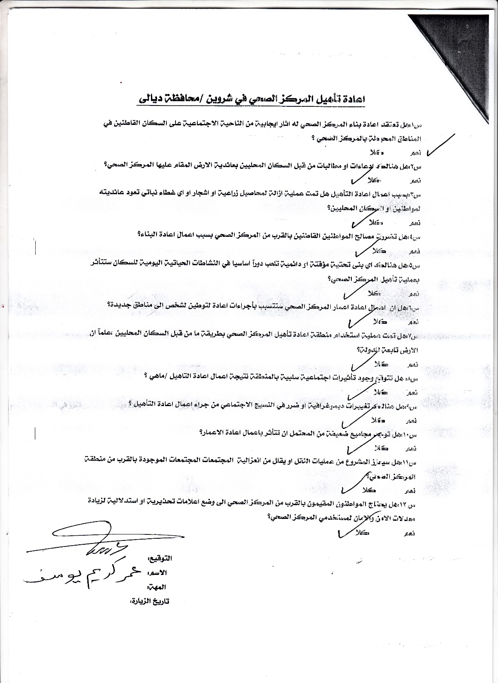
Name of the Respondent (7) | Alaa Mohammed Ahmed (Male)
Occupation of the Respondent | Teacher
Date | 17/6/2019

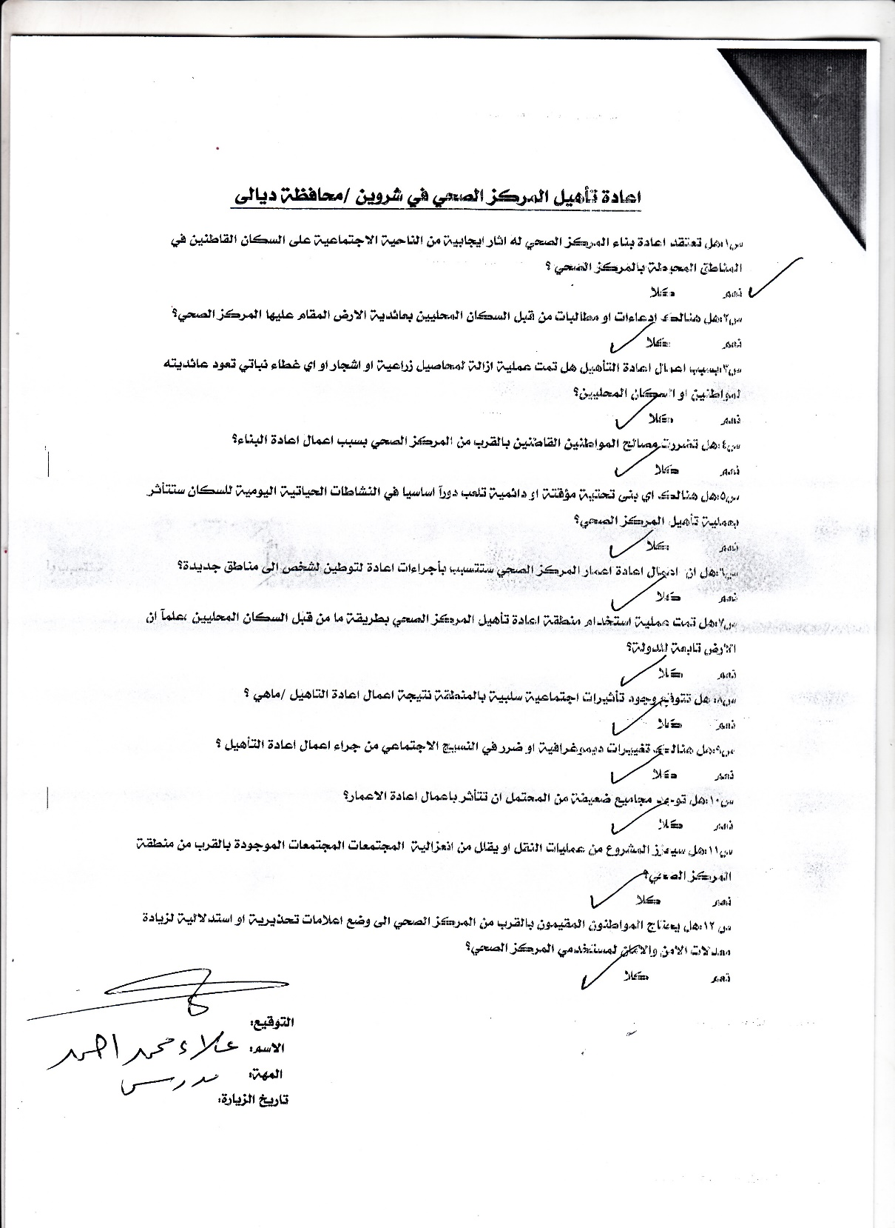
Name of the Respondent (8) | Omar Abd Mohammed (Male)
Occupation of the Respondent | Laborer
Date | 17/6/2019

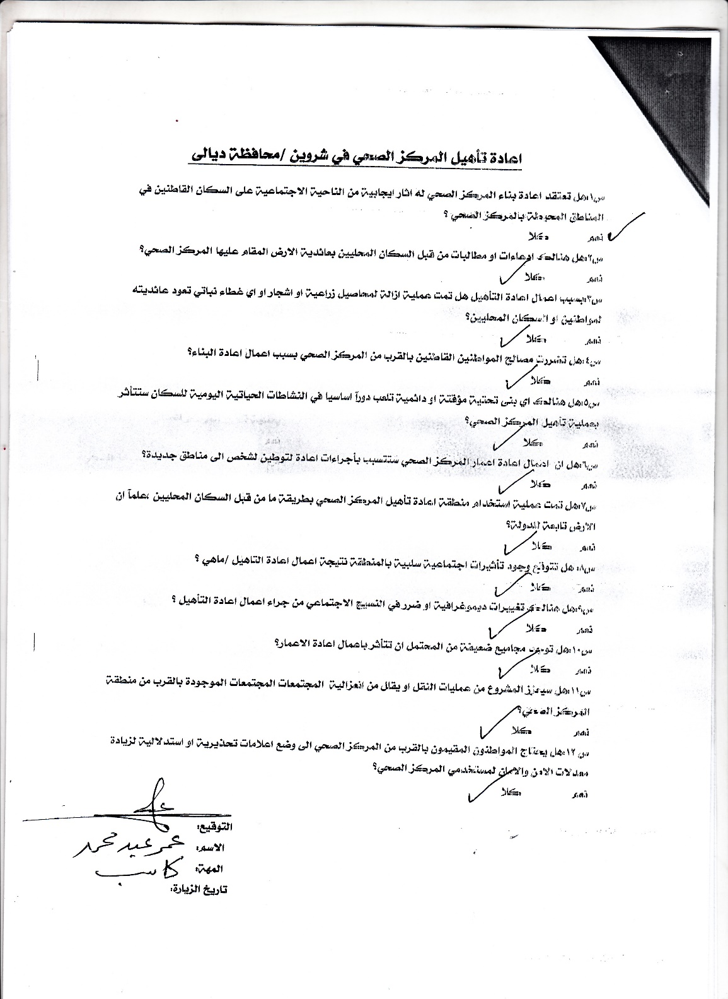
Name of the Respondent (9) | Hend Mahmood Hussein (Female)
Occupation of the Respondent | Engineer
Date | 17/6/2019

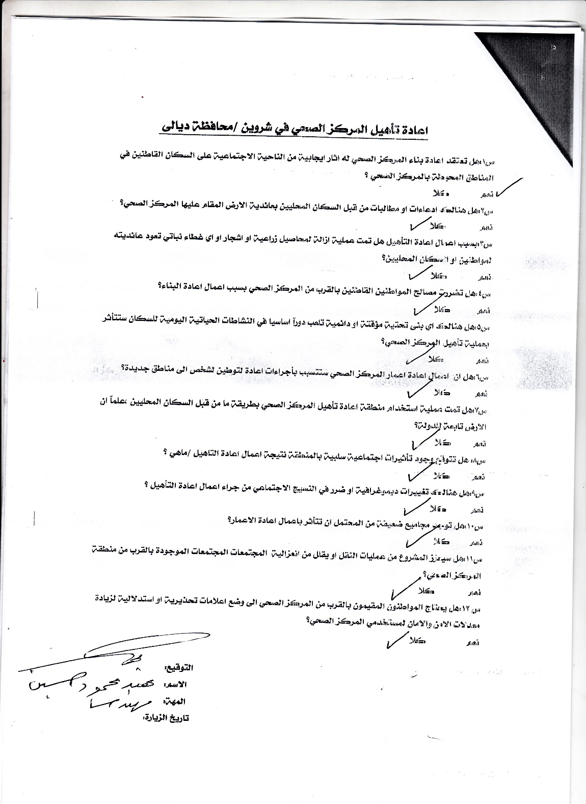
Name of the Respondent (10) | Mahmood Hussein Ali (Male)
Occupation of the Respondent | Engineer
Date | 17/6/2019

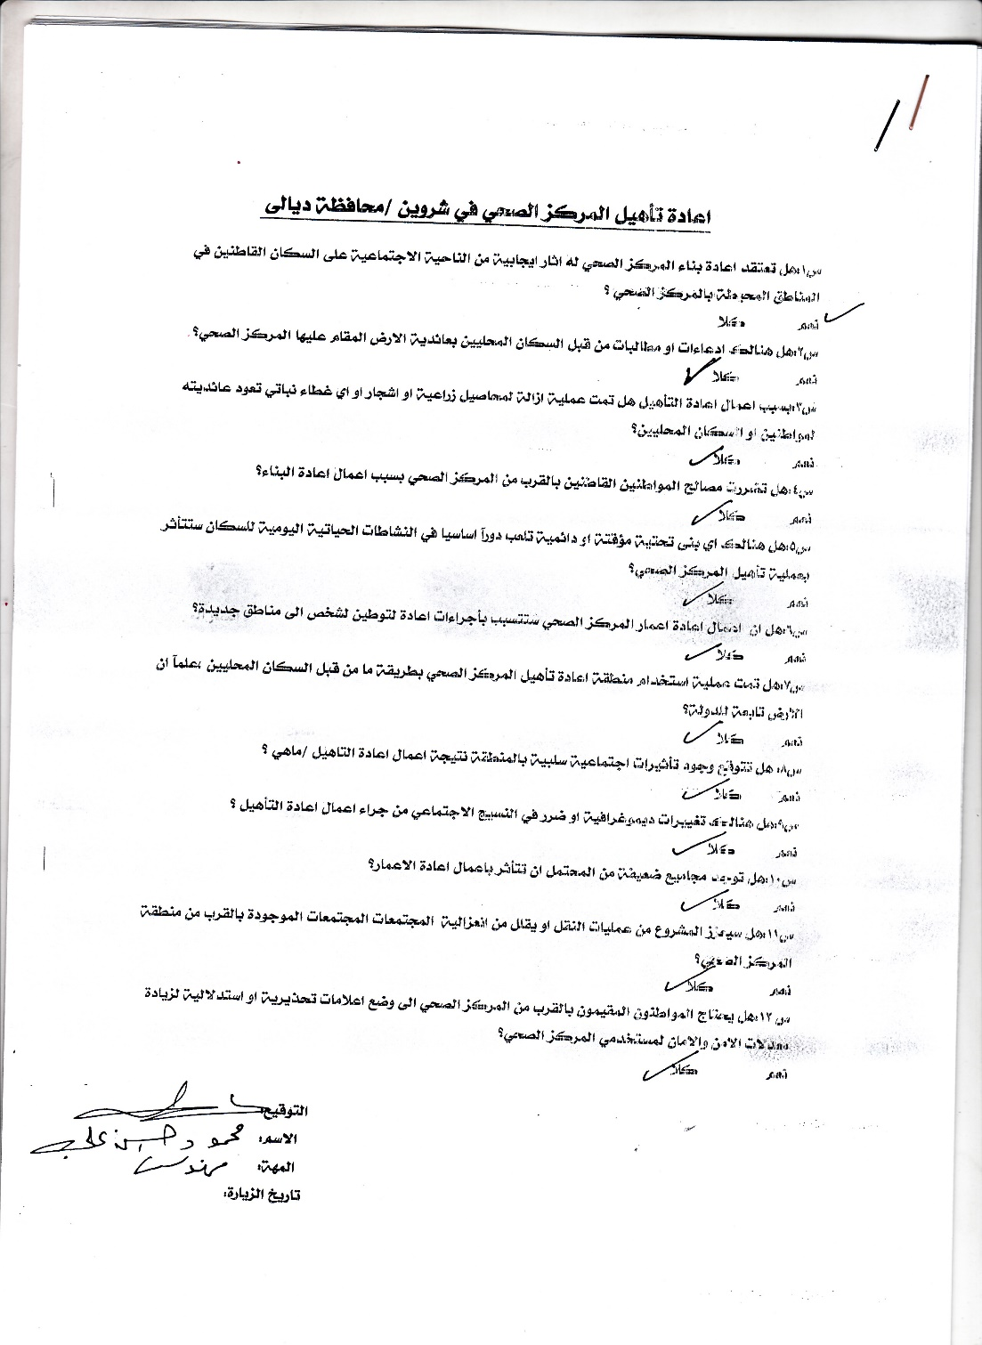

Name of the Respondent (11) | Wisam Ali (Male)
Occupation of the Respondent | Wage earner
Date | 27/8/2019
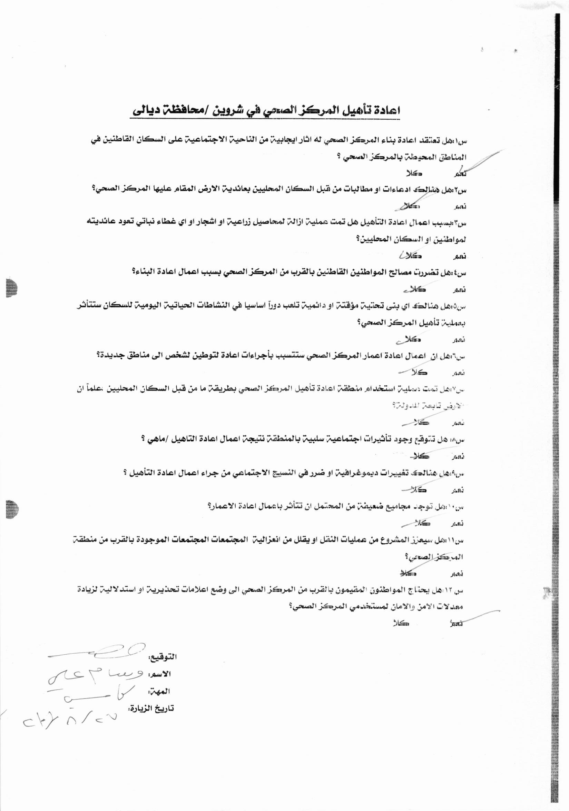
Name of the Respondent (12) | Mohammad Taefeeq (Male)
Occupation of the Respondent | Wage earner
Date | 27/8/2019

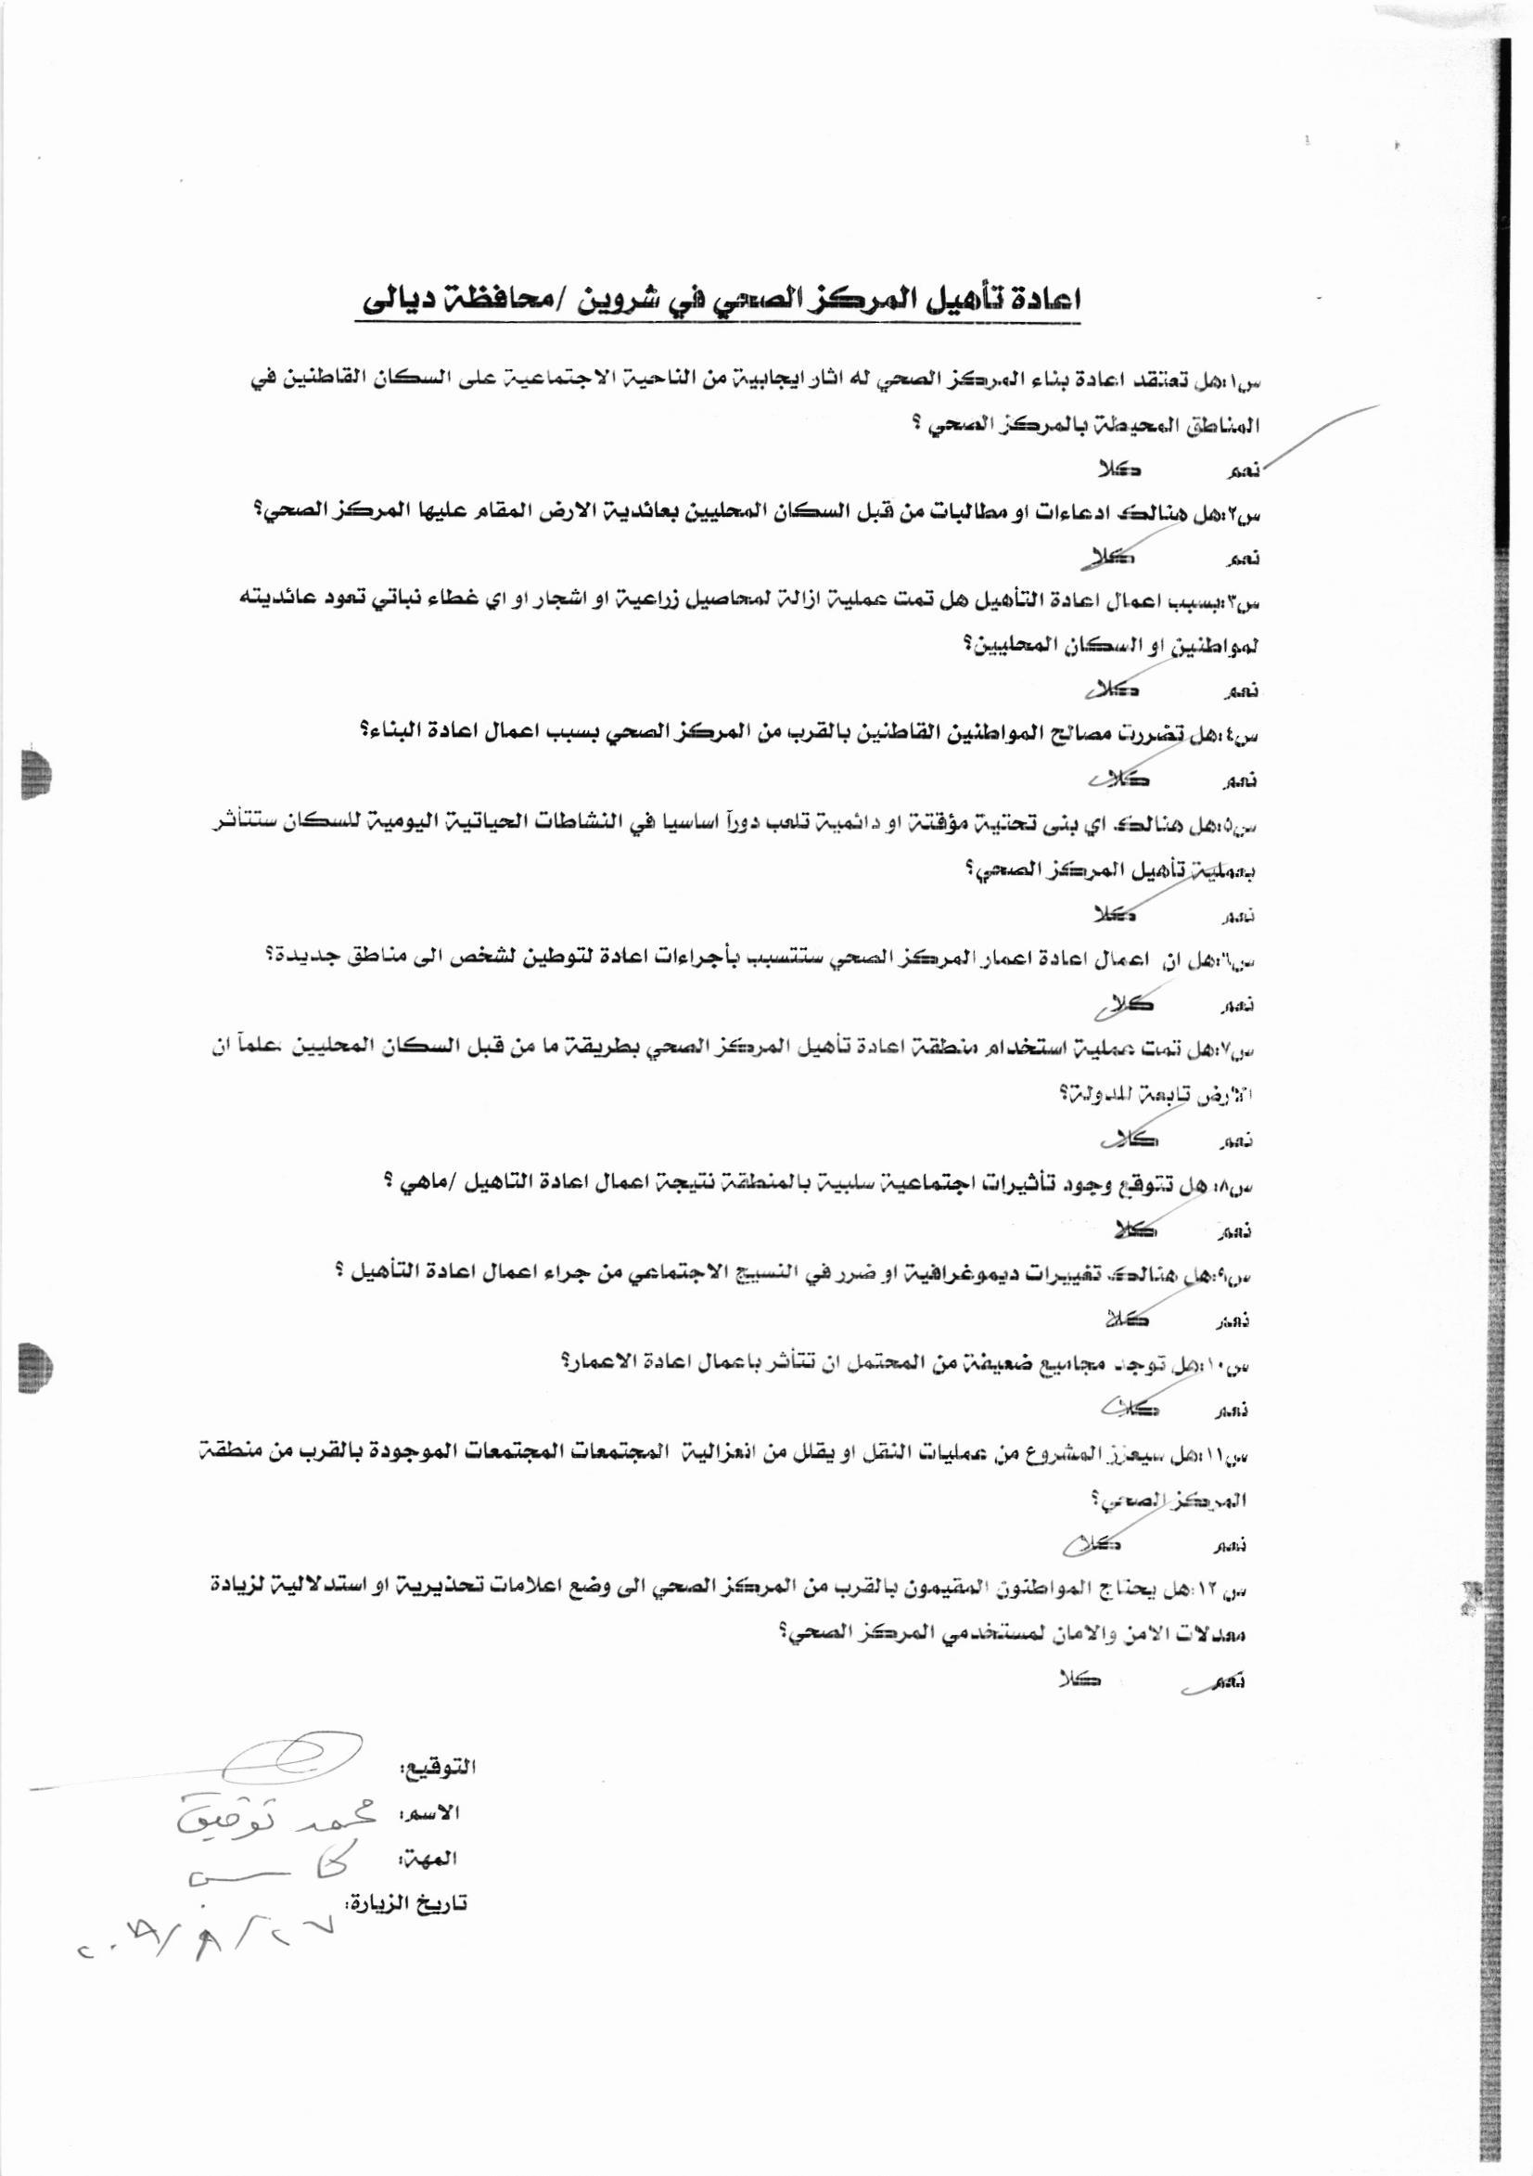

Name of the Respondent (13) | Shaimaa Mustafa (Female)
Occupation of the Respondent | Housewife
Date | 27/8/2019

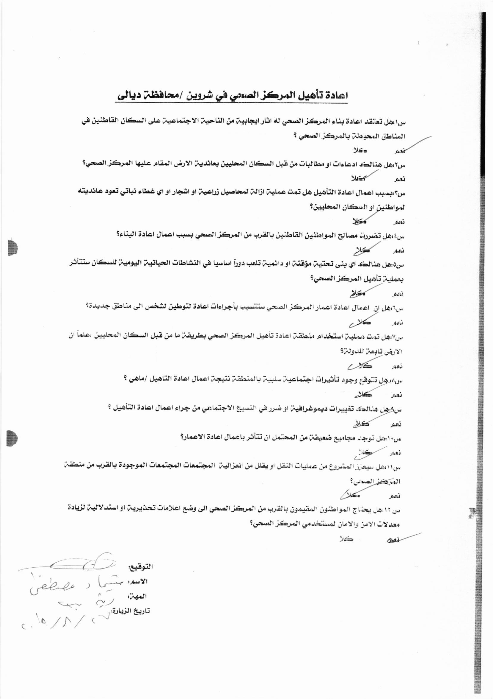
Name of the Respondent (14) | Fatima Ali (Female)
Occupation of the Respondent | Housewife
Date | 27/8/2019

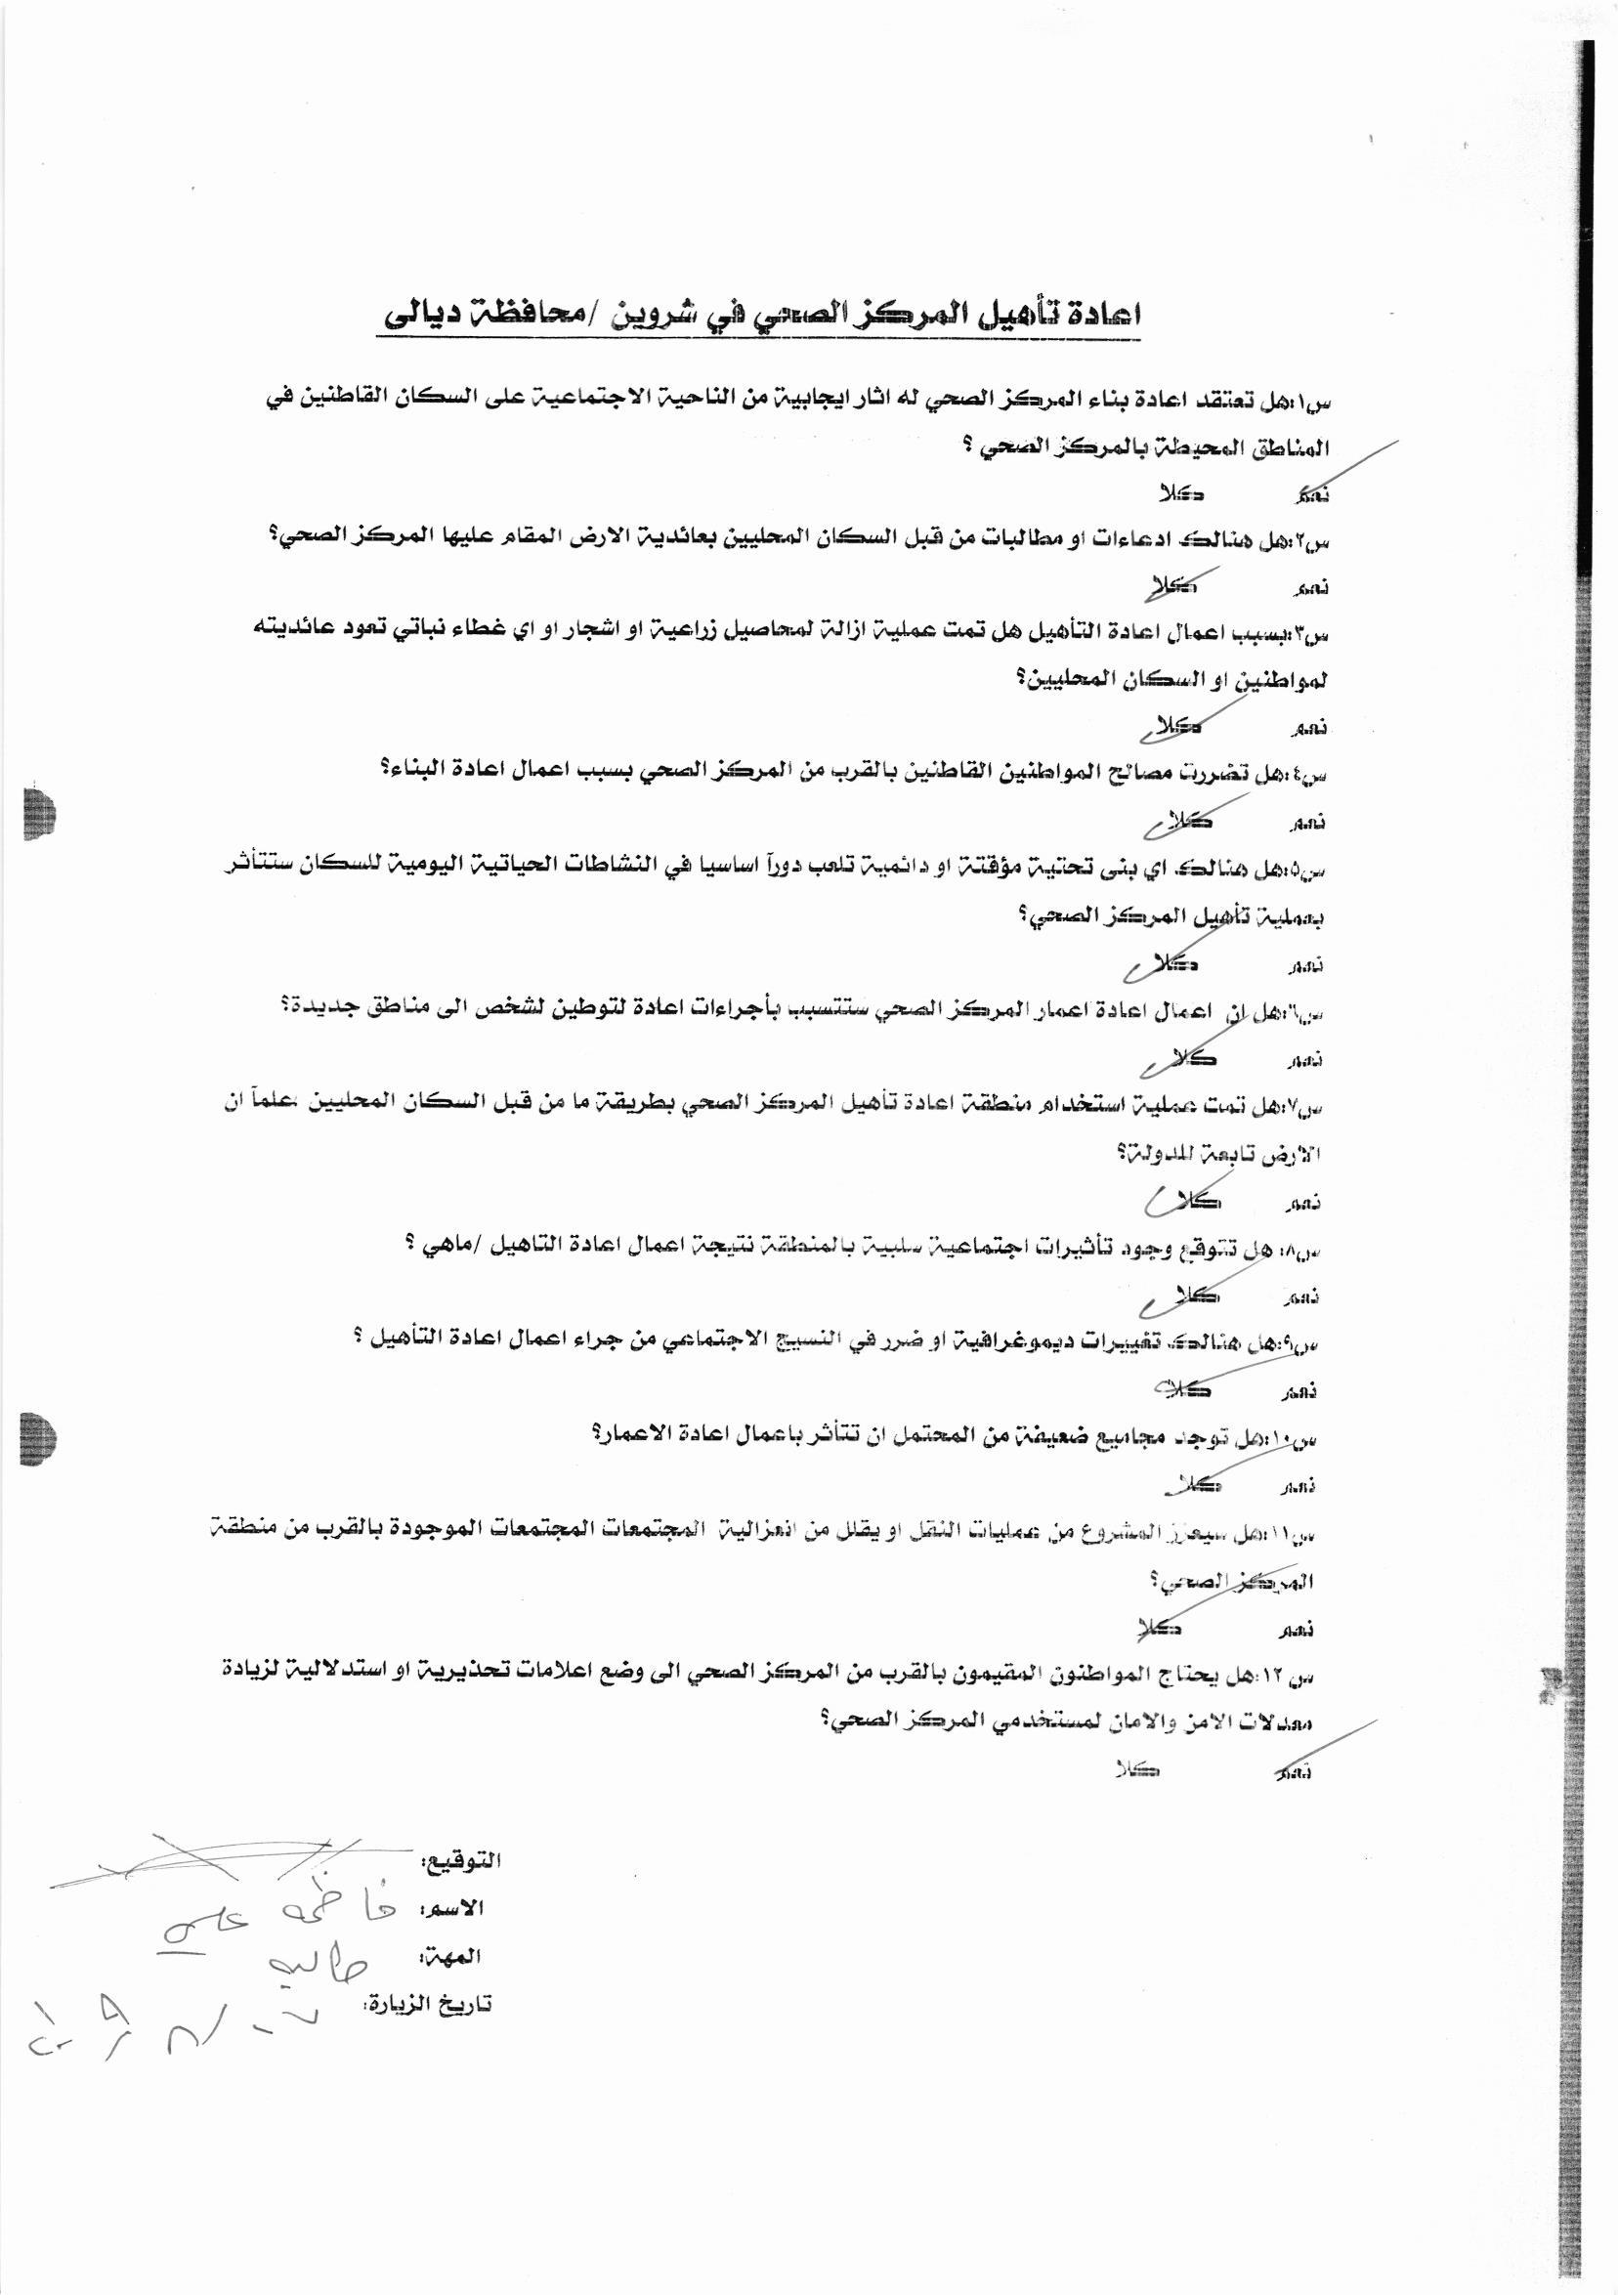
Name of the Respondent (15) | Rana Saber (Female)
Occupation of the Respondent | Housewife
Date | 27/8/2019

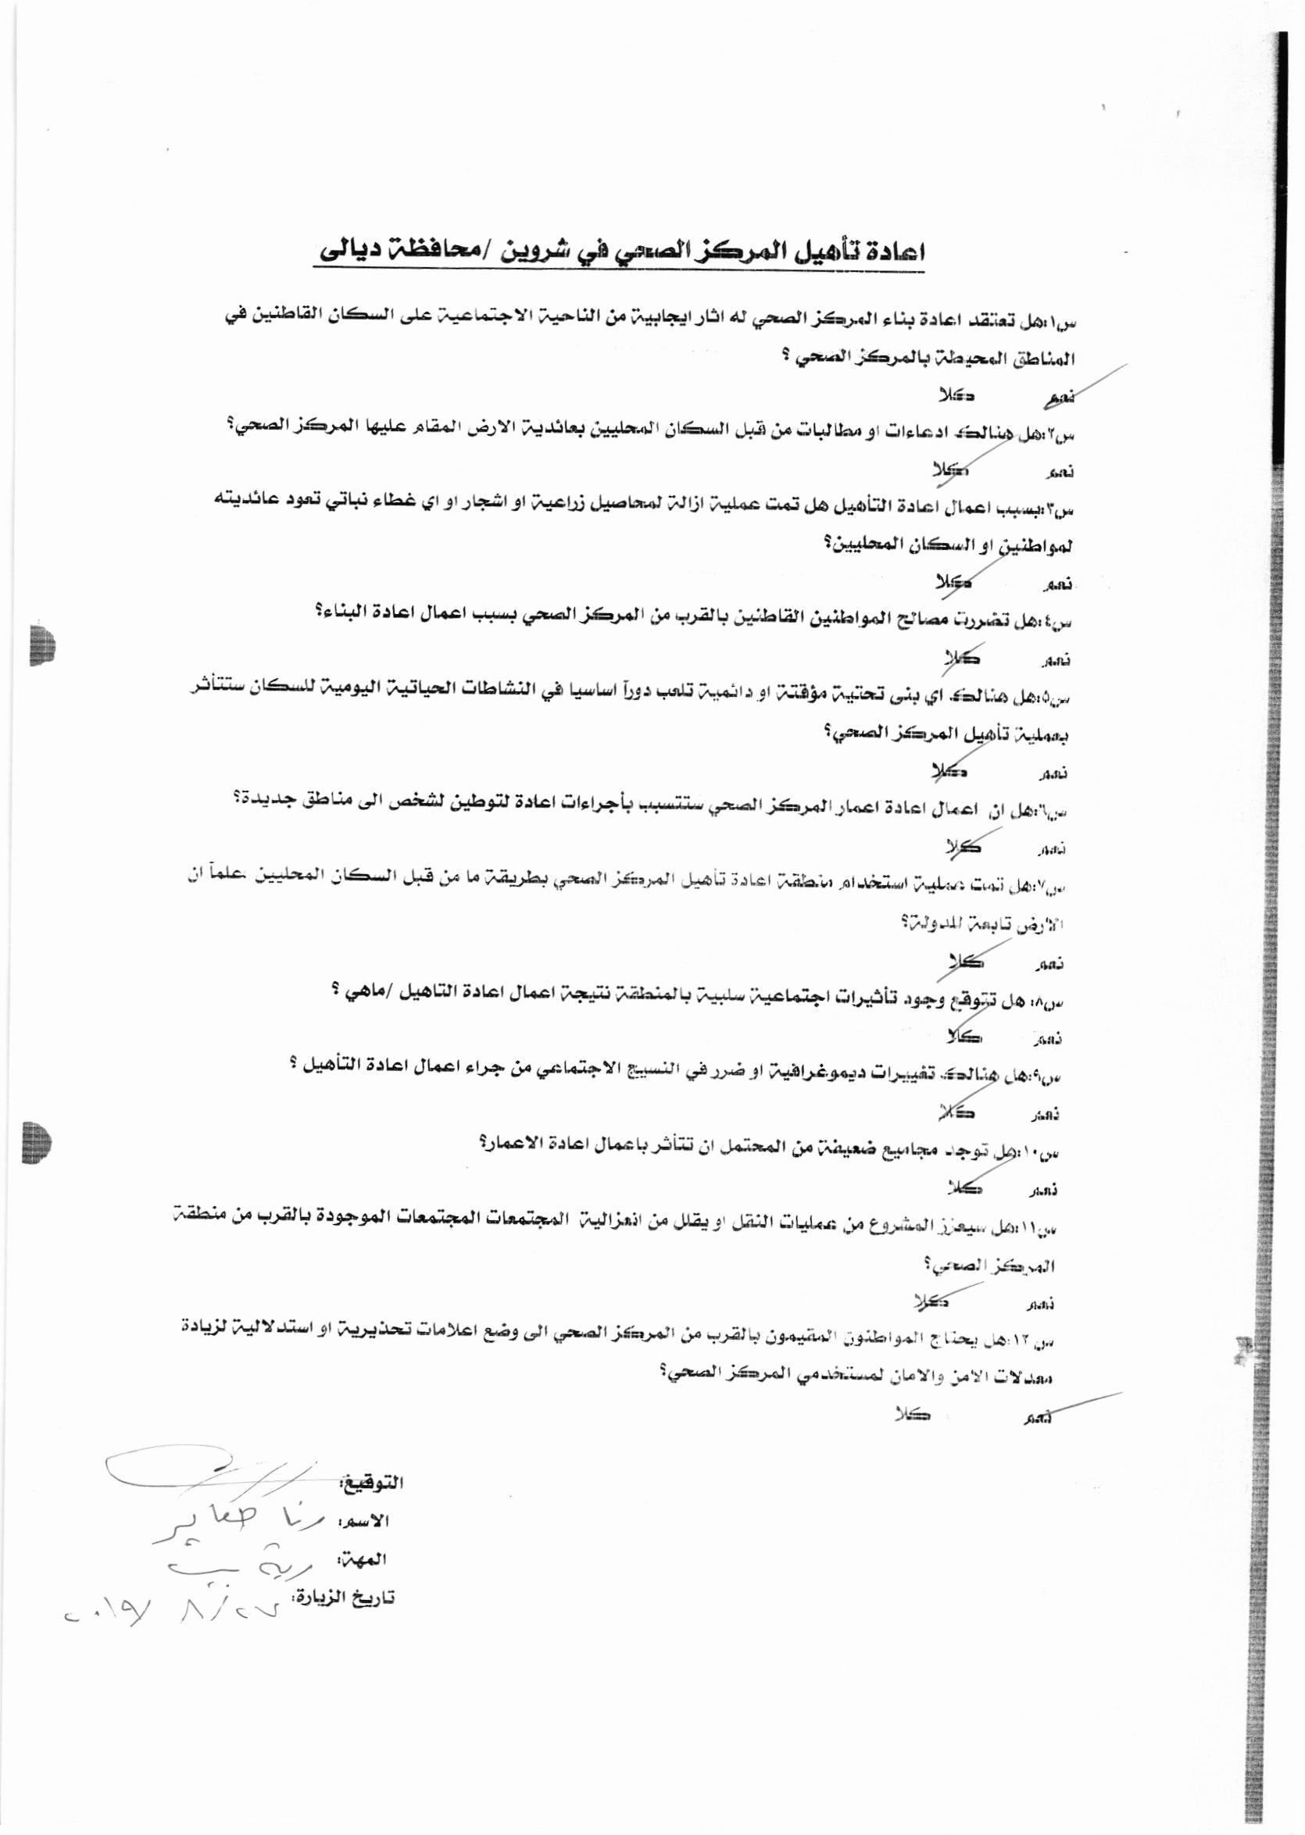
Name of the Respondent (16) | Zainab kadham (Female)
Occupation of the Respondent | Housewife
Date | 27/8/2019

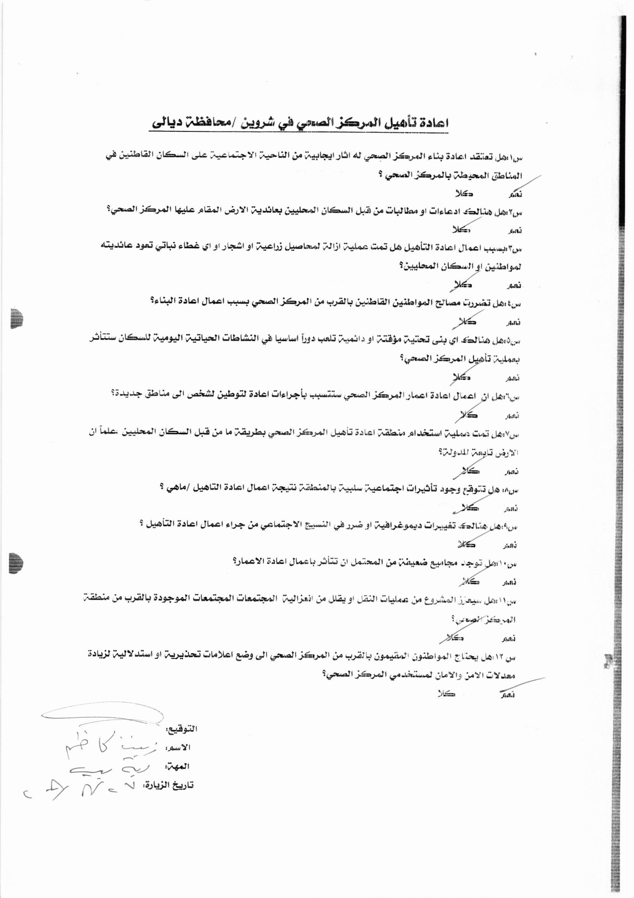
Name of the Respondent (17) | Sara Hameed (Female)
Occupation of the Respondent | Housewife
Date | 27/8/2019

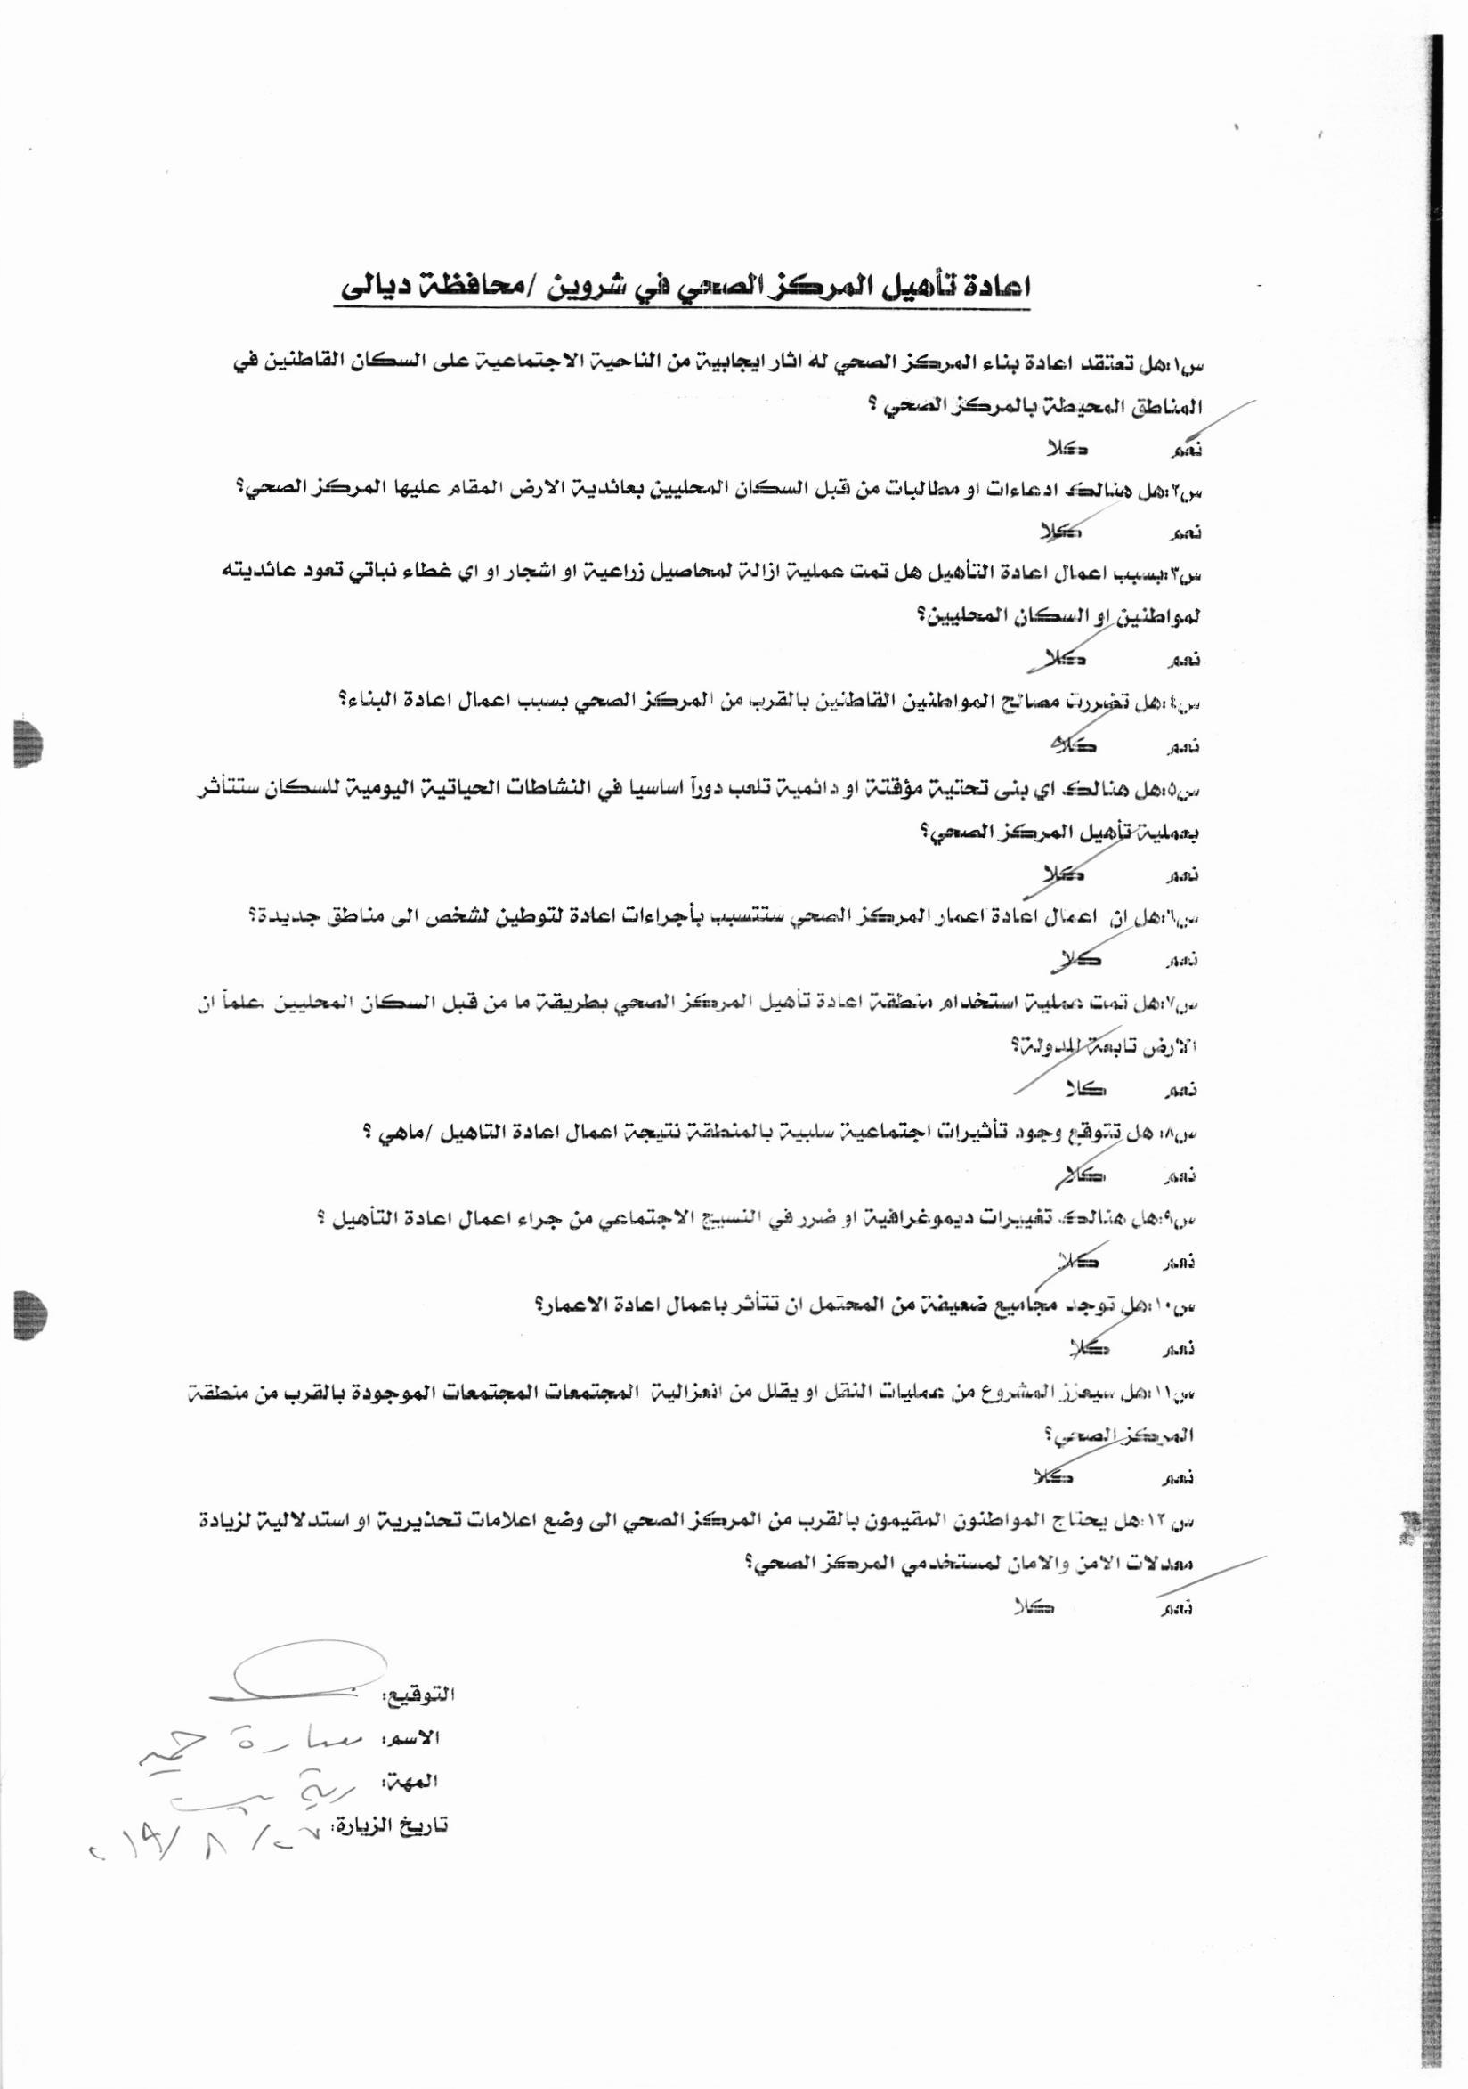
Name of the Respondent (18) | Sabreah Jasim (Female)
Occupation of the Respondent | Housewife
Date | 27/8/2019

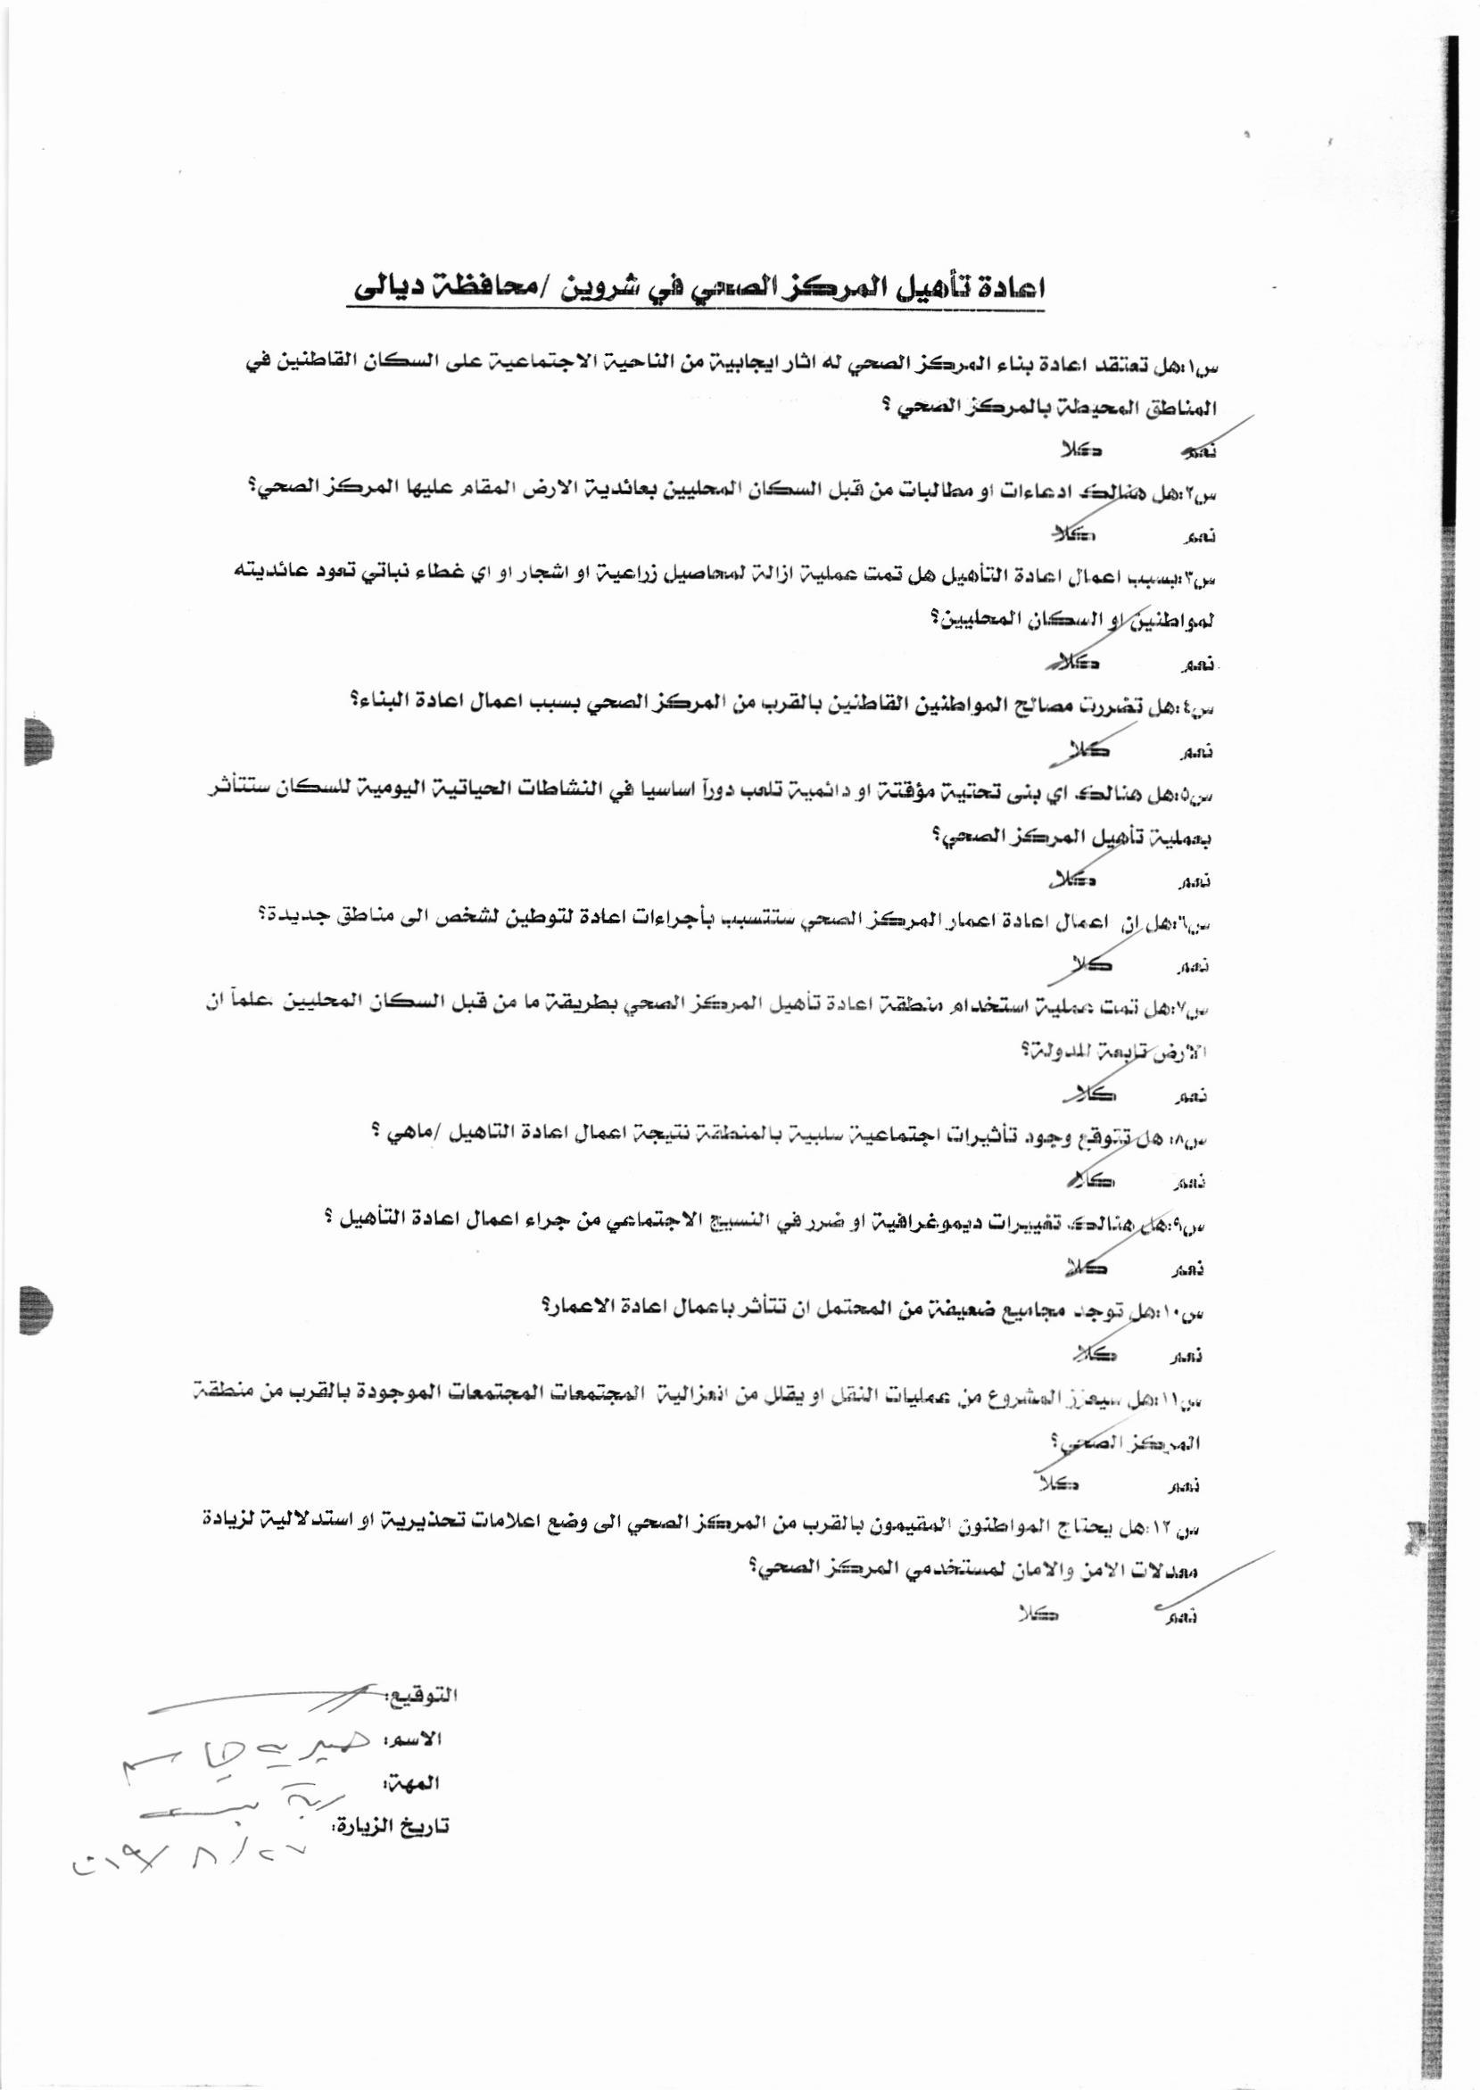
Name of the Respondent (19) | Noryiah Salim (Female)
Occupation of the Respondent | Housewife
Date | 27/8/2019

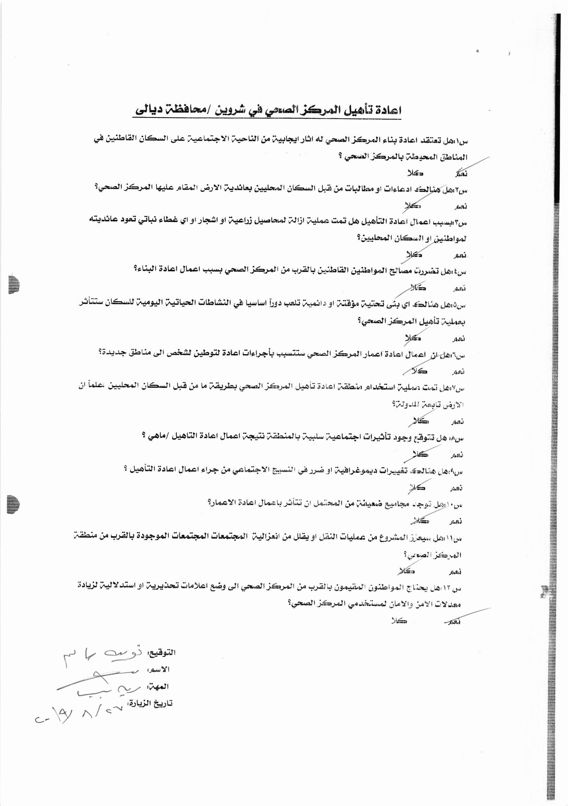
Name of the Respondent (20) | Subhiah Mohammad (Female)
Occupation of the Respondent | Housewife
Date | 27/8/2019

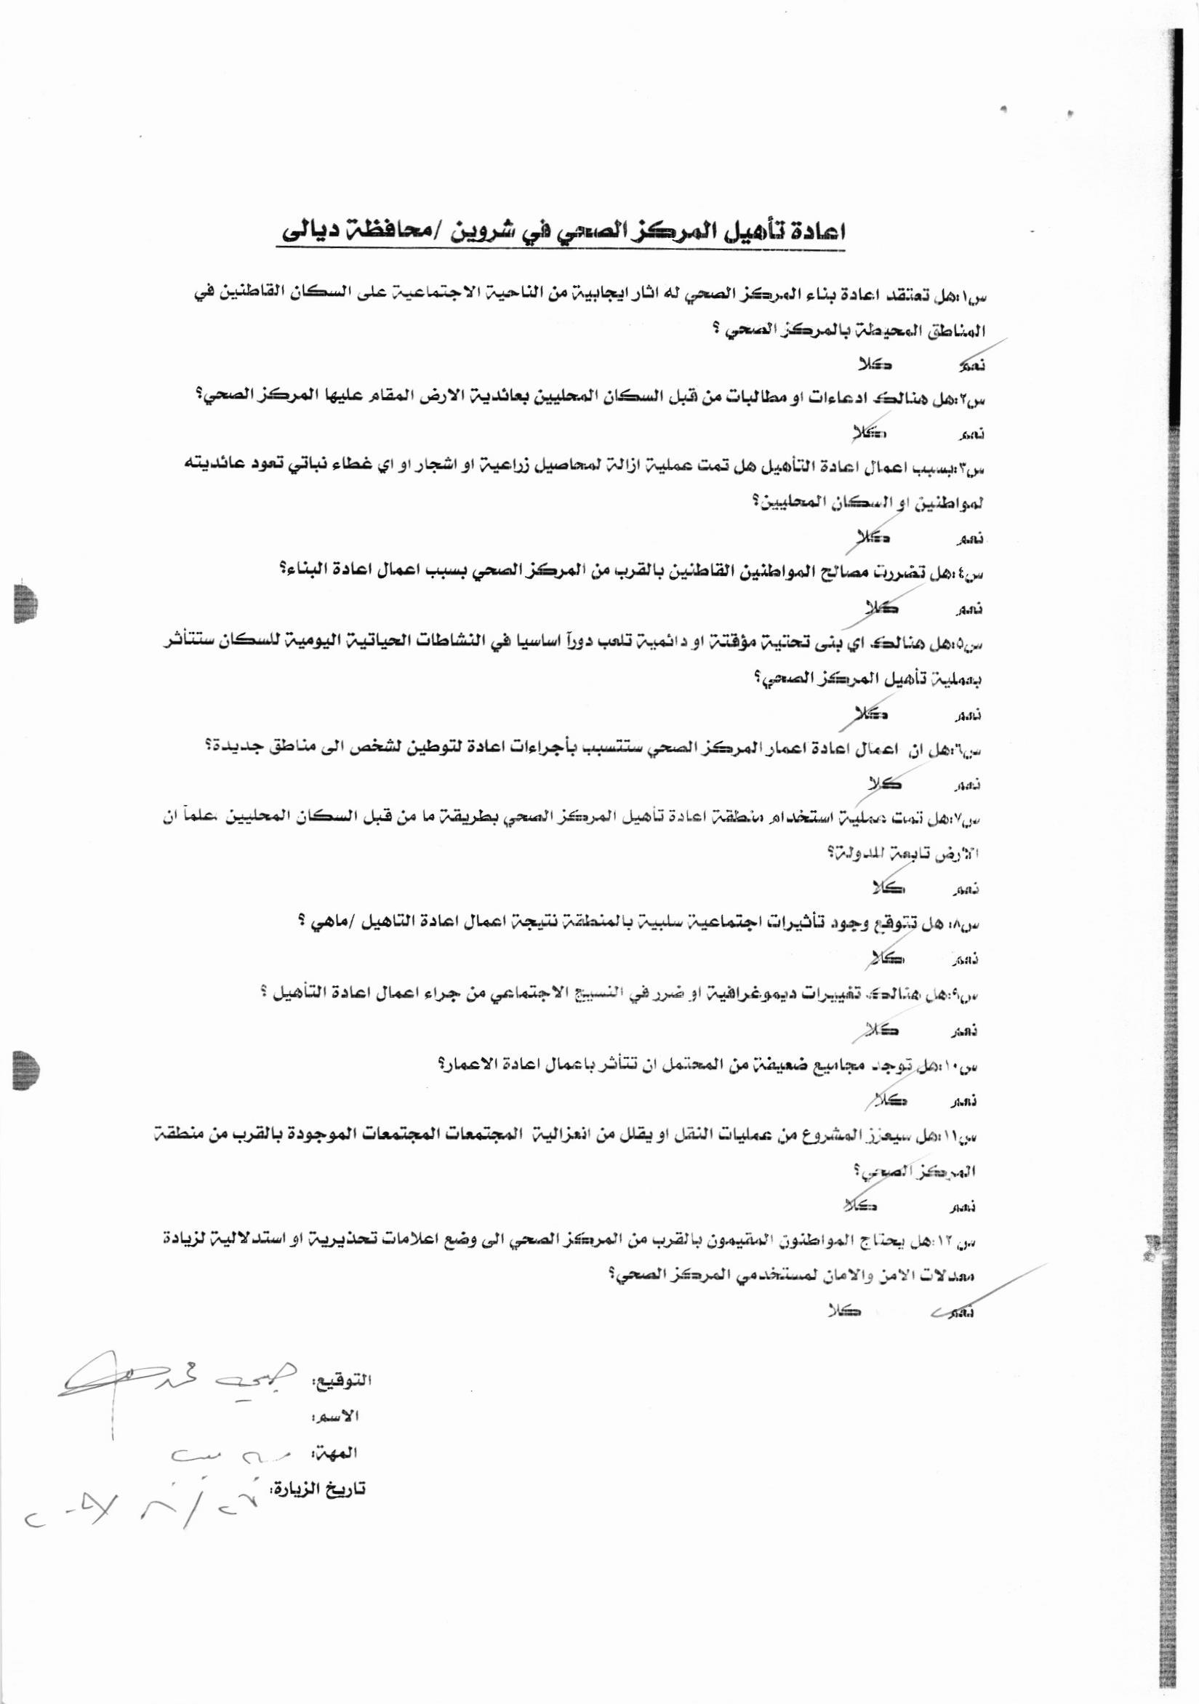

Photo taken during the consultations in the surroundings of Sharween Clinic on June 17, 2019

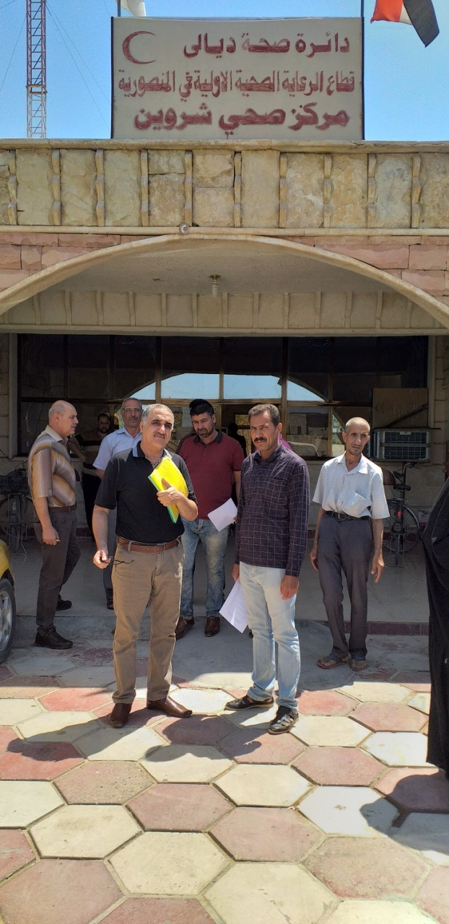

Document stating that a public consultation was conducted on September 3, 2019 in Mansouriya Pilot Clinic and discussions were undertaken with the attendees. Questions were raised and answered and all the attendees expressed their full support to the Project

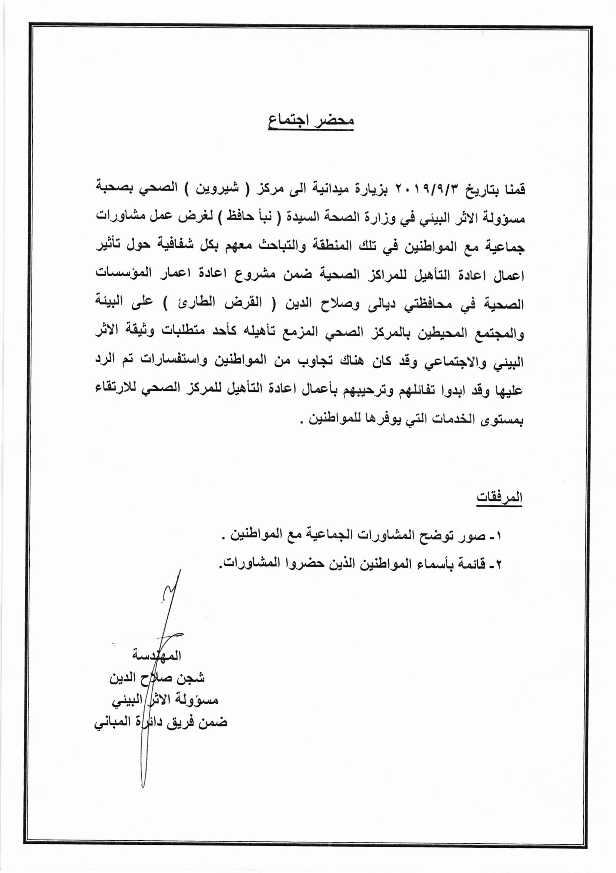

List of people who attended the public consultation that was conducted on September 3, 2019 in Sharween Clinic

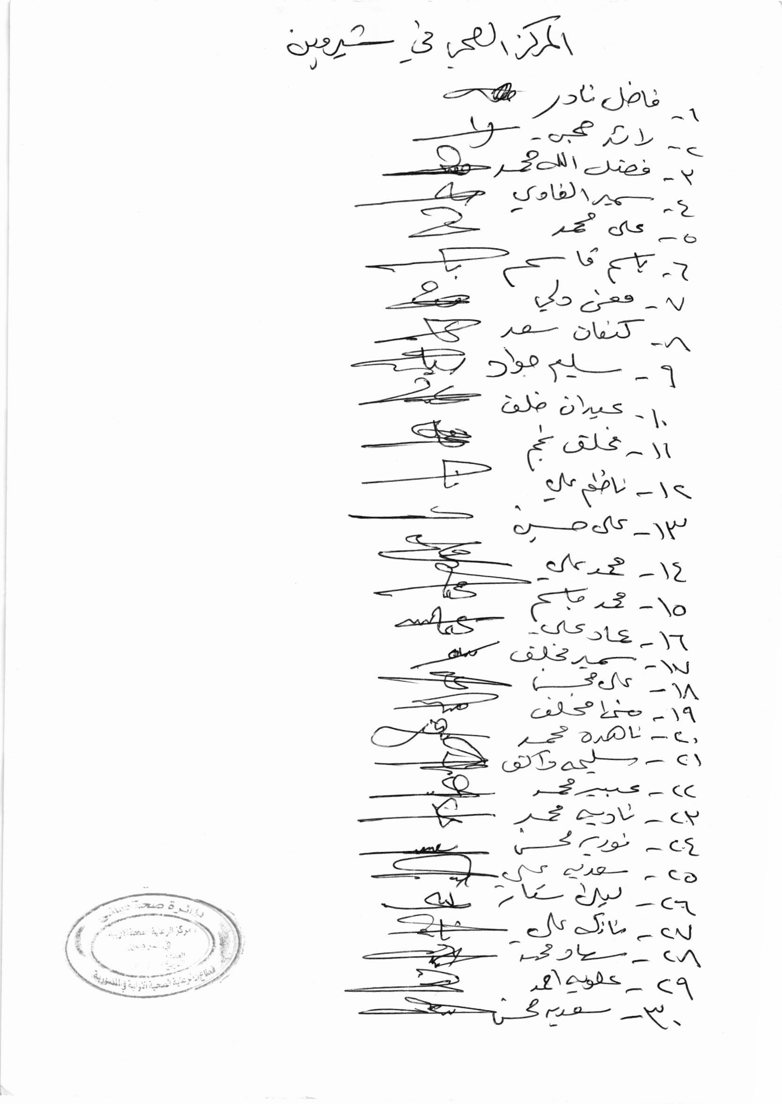

Photos taken during consultation on August 27, 2019
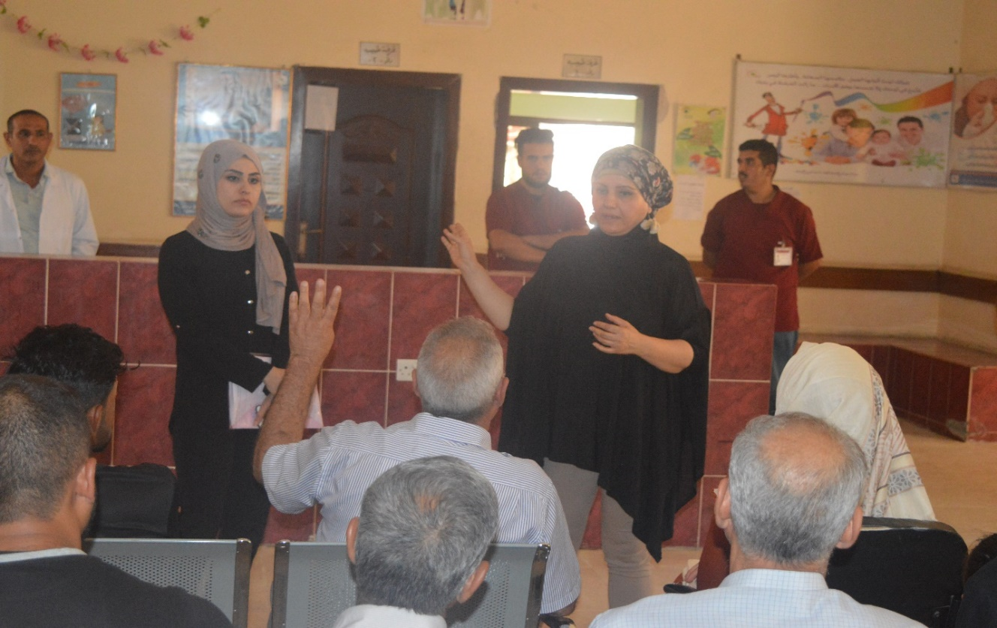
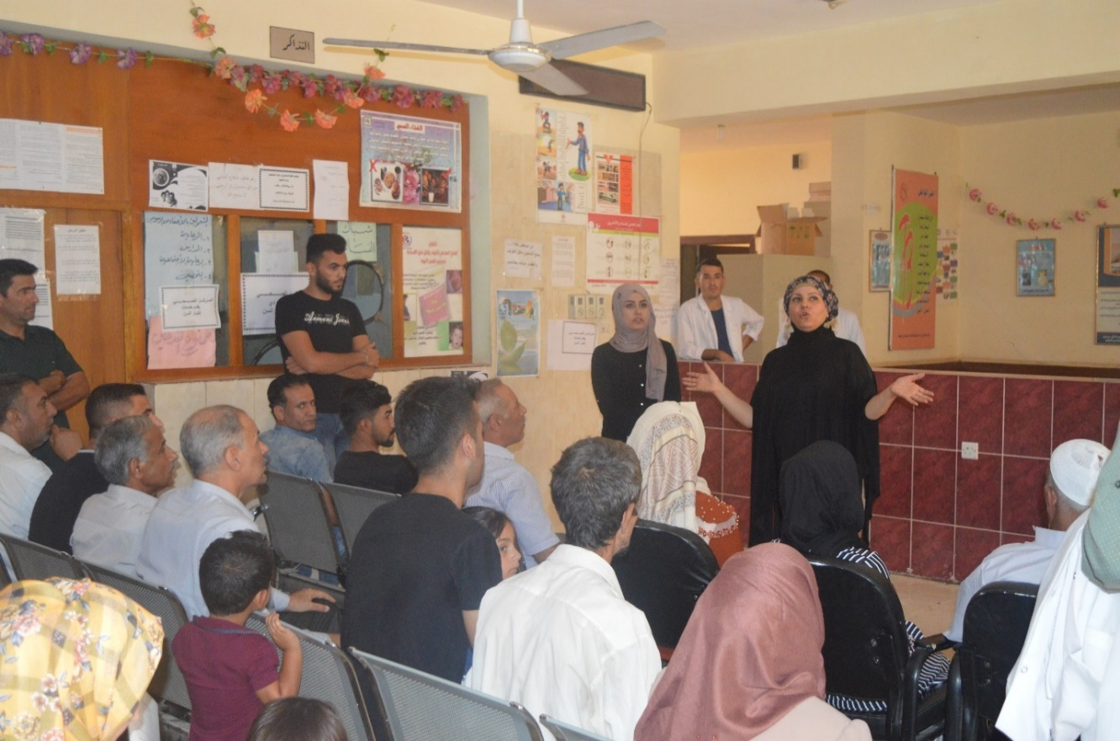

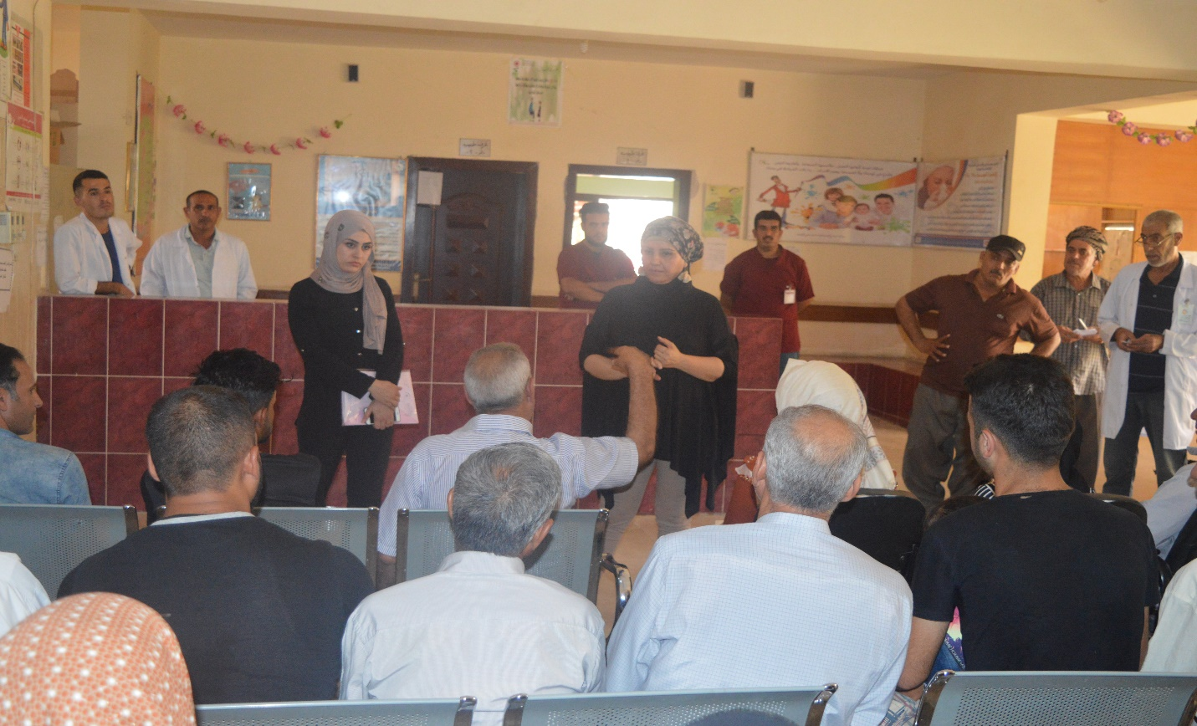
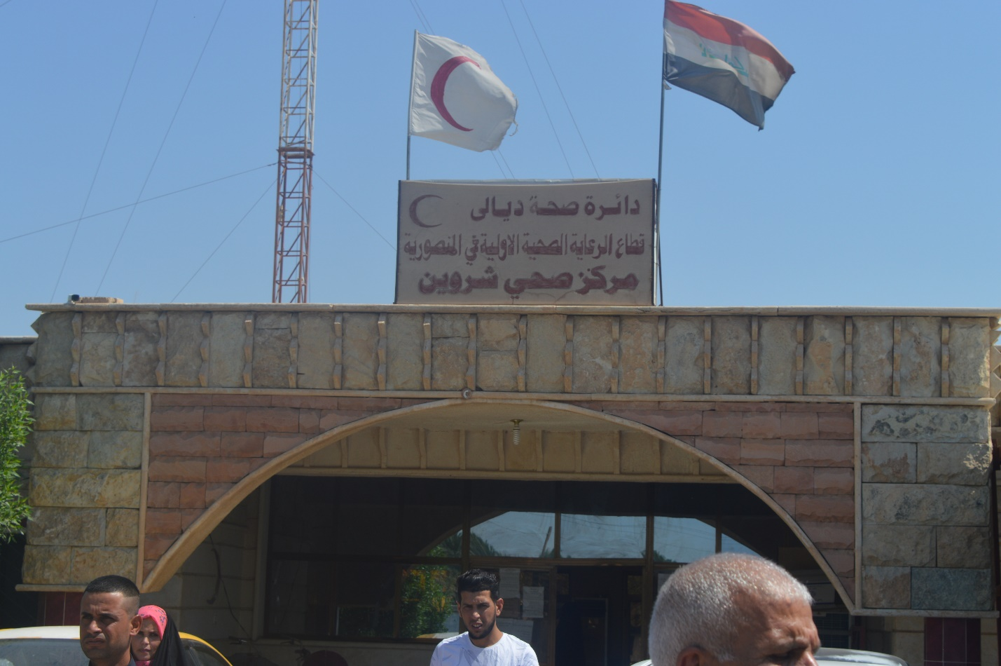

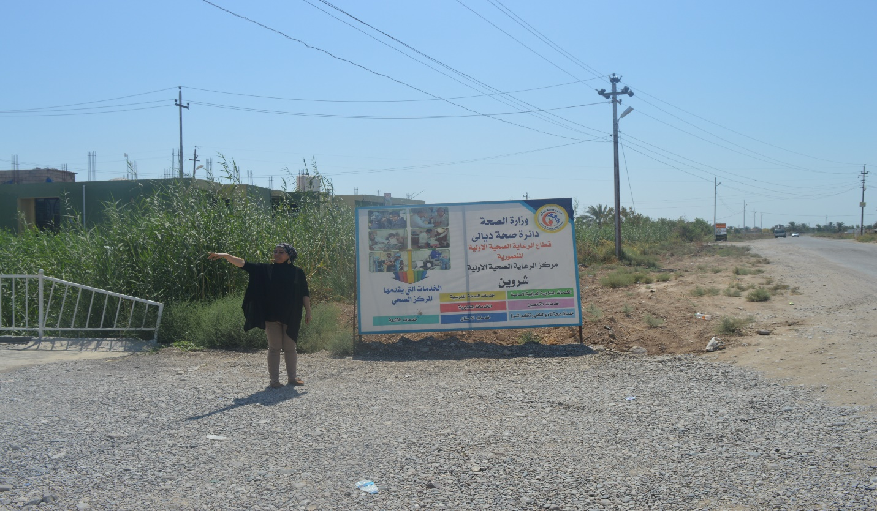
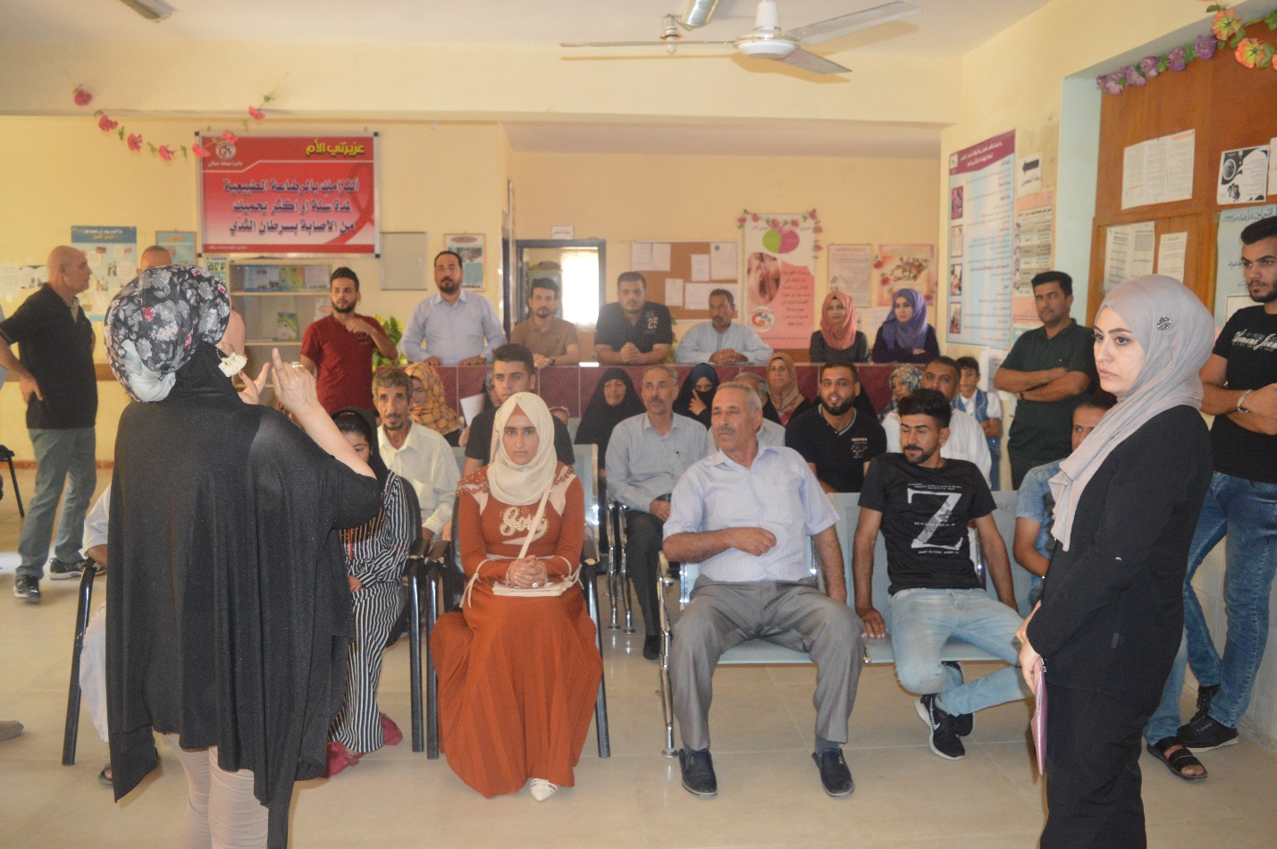
Annex 4: Letter from Ministry of Health confirming that all the Health Care Clinics are currently operational except Rabiaa
Annex 4: Letter from Ministry of Health confirming that all the Health Care Clinics are currently operational except Rabiaa 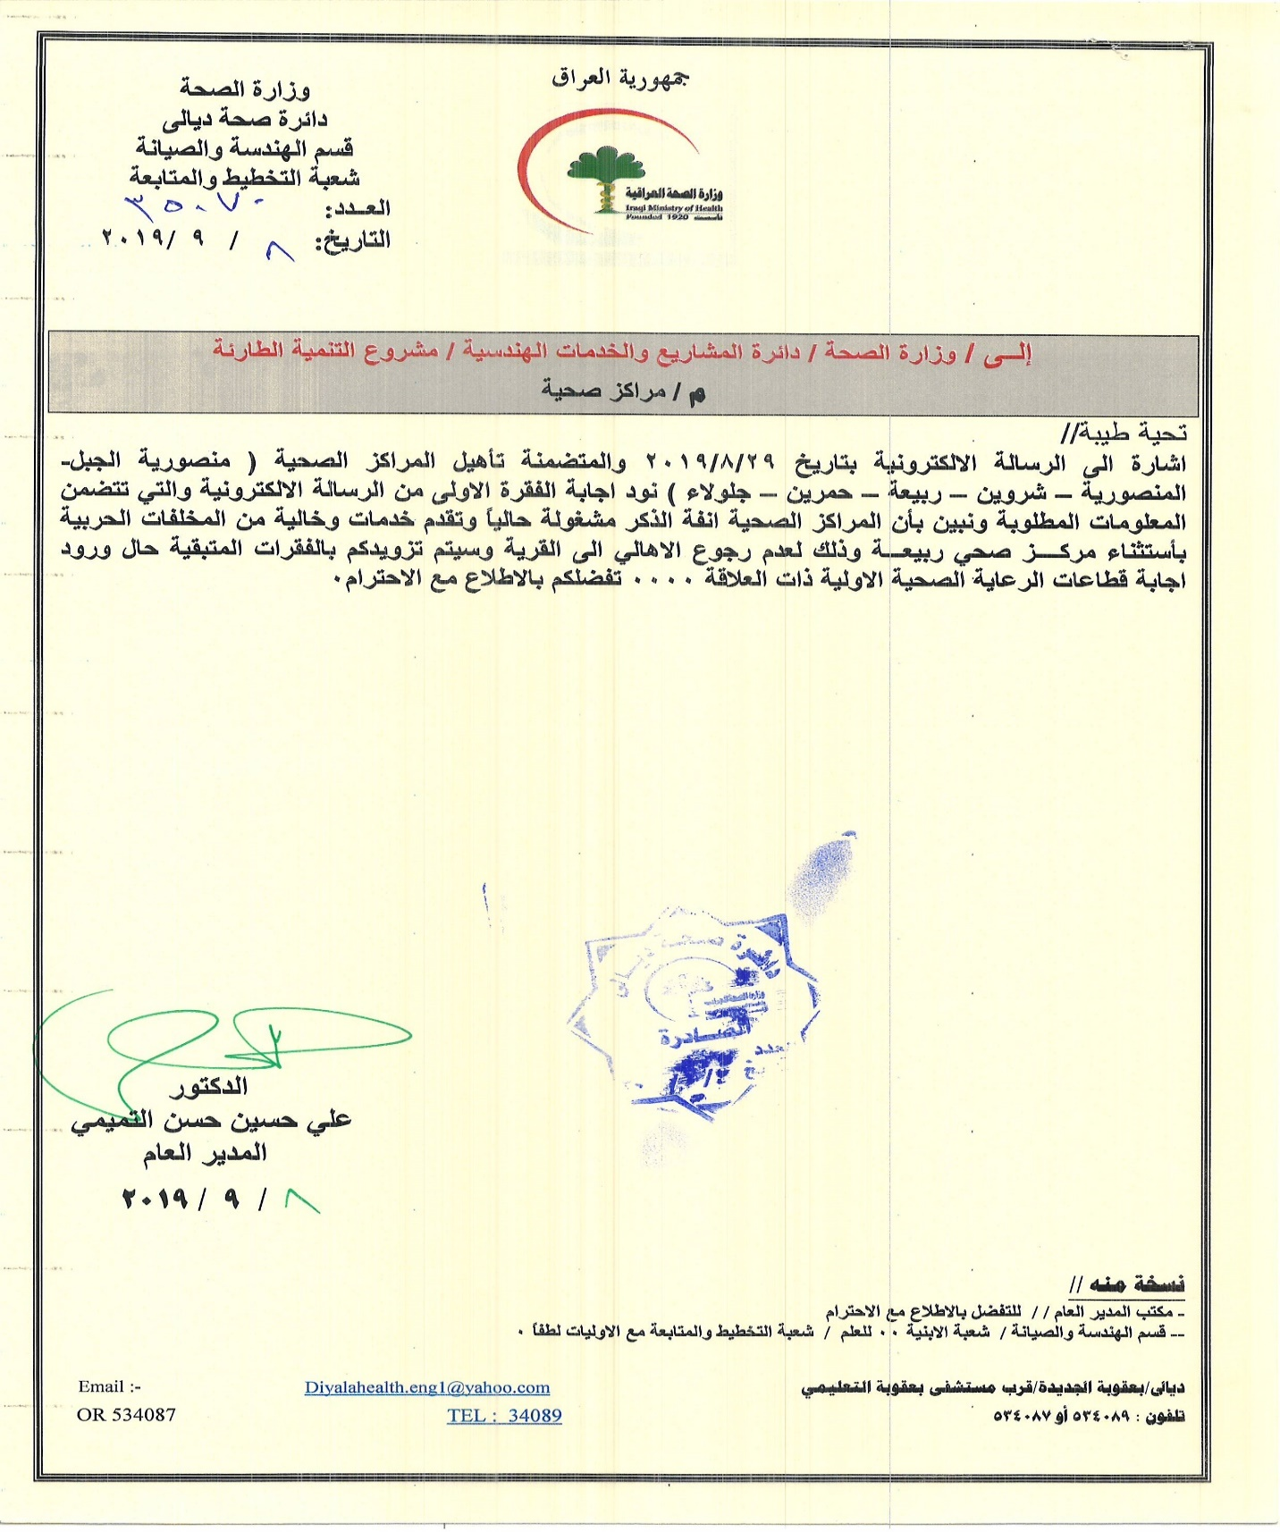
Annex 5: Medical Wastes Management Plan
Following are preliminary information needed for the Medical Waste Management Plan. A detailed Plan will be submitted later and included in the Contractor’s contract.

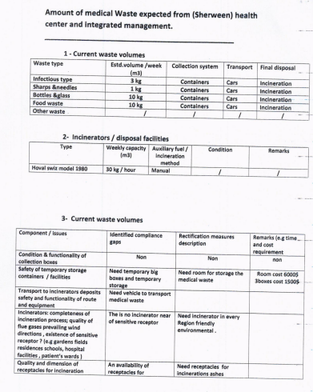

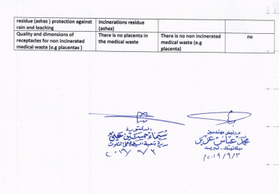

Land acquisitions includes displacement of people, change of livelihood encroachment on private property this is to land that is purchased/transferred and affects people who are living and/or squatters and/or operate a business (kiosks) on land that is being acquired.
Toxic / hazardous material includes, but is not limited to, asbestos, toxic paints, noxious solvents, removal of lead paint, etc.

